

E-Business

Yuxiao Zhang [yuz119@pitt.edu](mailto:yuz119@pitt.edu)

Yiyuan Xie [yix47@pitt.edu](mailto:yix47@pitt.edu)

Yang Wang [yaw56@pitt.edu](mailto:yaw56@pitt.edu)

Project Report

Database Management Fall 2016

Table of Contents

1. Overview 3

2. Assumptions 3

3. Graphic schema of the database of E-R diagram 3

4. Relational schema 6

4.1 Address 6

4.2 Business 6

4.3 Business_Customer 7

4.4 Business_Transaction 7

4.5 Home 8

4.6 Home_Customer 8

4.7 Home_Transaction 9

4.8 Product 9

4.9 Region 10

4.10 Salesperson 10

4.11 Store 10

4.12 Zipcode 11

5. The DDL statements 11

6. Front-end and back-end design 17

6.1 Front-end design 17

6.2 Back-end design 17

7. Overview of the system implementation 17

7.1 Customer Interfaces 17

7.1.1 Login 17

7.1.2 Log-up 18

7.1.3 Region Choosing 20

7.1.4 Store and Salesperson Choosing 21

7.1.5 Browsing Interface 22

7.1.6 Transaction details 24

7.1.7 View Past Orders 25

7.1.8 Statistic of the Shop 26

7.2 Administrator Interfaces 28

7.2.1 Add products 29

7.2.2 Modify products 31

7.2.3 Delete products 32

7.2.4 Manage Customers 34

8. Testing of Erroneous Cases 37

8.1 Erroneous Cases when Log up 37

8.1.1 Different Passwords 37

8.1.2 Duplicate Username 37

8.1.3 Input Error Messages in Zip Code, Age and Income 38

8.2 Erroneous Cases when Log in 40

8.3 Erroneous Cases when Making Transactions 40

8.4 Erroneous Cases when Adding New Products 41

8.4.1 Adding Existed Products 41

8.4.2 Input Negative Value or Error Information on Price and Inventory Amount 42

9. Reviews and Improvements 43

# 1. Overview

Our team has finished the database system for E-Business that can achieve multiple tasks. The users are divided into two parts: Home customer and Business customer. They can both use the function of system including logging in, logging out, signing up, region choosing, store and salesperson choosing, browsing, searching and buying. The administrator can add new product, modify existing products and delete products. And the system also has ability to test errors. It will test if there is an error existing when logging up, logging in, making transactions, adding new products and modifying products. Through the project, we use HTML5, CSS and JavaScript in Front-end design and use PHP in the Back-end design.

# 2. Assumptions

(1) Salesperson with same job title do not necessarily have the same salary.

(2) Customers are only Home customers and Business customers.

(3) A zip code can only exist in one city, but a city can have many zip codes.

(4) The inventory amount is updated in time without any delay.

(5) Information of store managers and region managers are also collected in the table Salesperson.

# 3. Graphic schema of the database of E-R diagram

The E-R graph is shown as below. In this graph, customers will be divided into two parts: Home_customer and Business_customer. They will include basic information of customers. The Home_customers have a home, which contains basic home information like gender or marriage status. The Business_customers are related to business, which stores business information like company name. When customers make a transaction, information will be stored in business or home transaction. The information of the deal will be stored in these two parts. The product will save information of all products, and it provides the foreign key of Home_customer and Business_customer. There is ombudsman sell goods, and their information will be saved in Salesperson. Address include all people’s (salesperson, customer) addresses. There is also a zipcode set as a supplement of address. We divide those two because of the BCNF form.

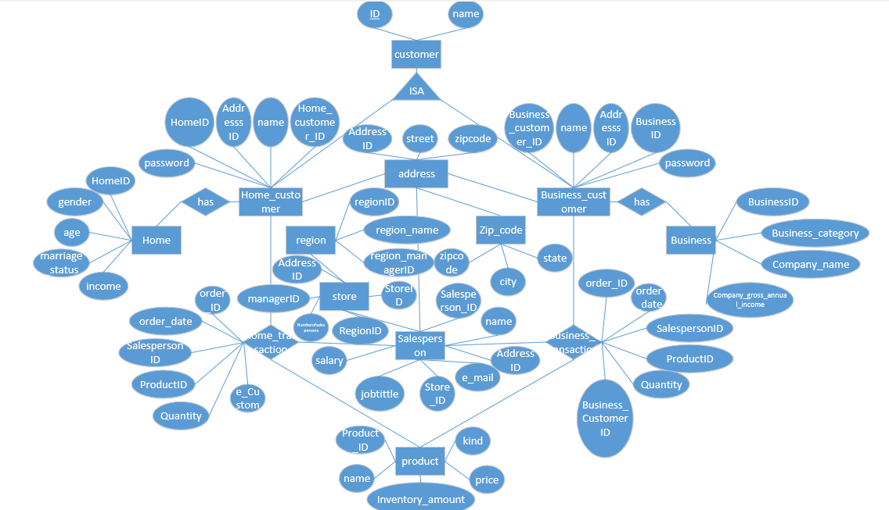

*Figure 3.1 E-R diagram*

# 4. Relational schema

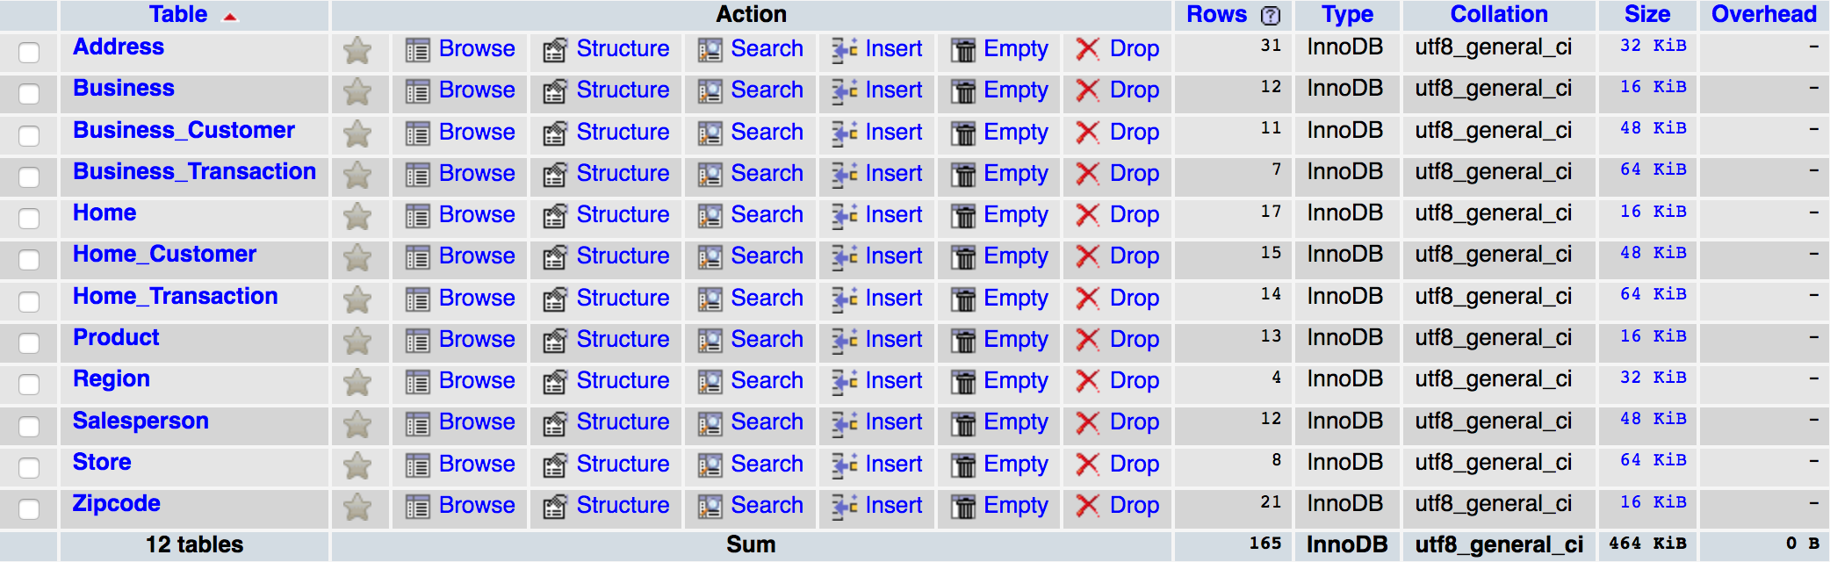

*Figure 4.1 All the Relations*

## 4.1 Address

Primary key of Address is AddressID.

Foreign key is zipcode which references relation “Zipcode”.

FDs: AddressID→street, AddressID→zipcode;

So it is a BCNF.

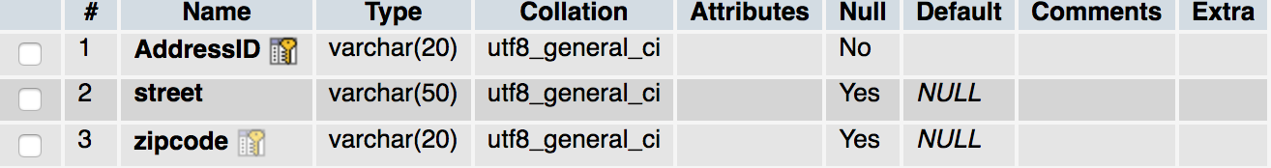

*Figure 4.2 Address*

## 4.2 Business

Primary key of business is BusinessID.

FDs: BusinessID→business_category, BusinessID→company_name, BusinessID→company_gross_annual_income;

It is a BCNF.

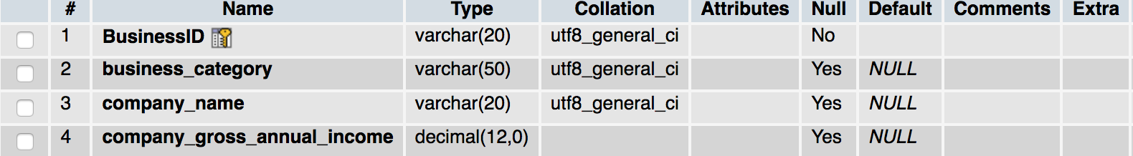

*Figure 4.3 Business*

## 4.3 Business_Customer

Primary key of Business_Customer is Business_customer_ID.

Foreign key of Business_Customer is BusinessID which references relation “Business”.

FDs: Business_CustomerID→name, Business_CustomerID→name, Business_CustomerID→AddressID, Business_CustomerID→password;

It is a BCNF.

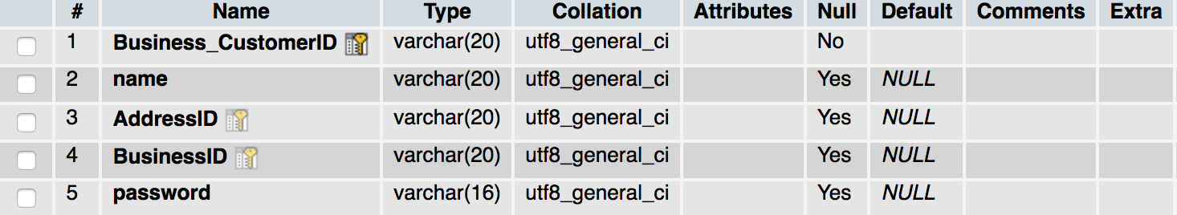

*Figure 4.4 Business_Customer*

## 4.4 Business_Transaction

Primary key of business_transaction is order_ID.

The foreign key of business_transaction are SalespersonID, ProductID, Business_Customer_ID.

FDs: orderID→order_date, orderID→SalespersonID, orderID→ProductID, orderID→quantity, orderID→Business_CustomerID;

It is a BCNF.

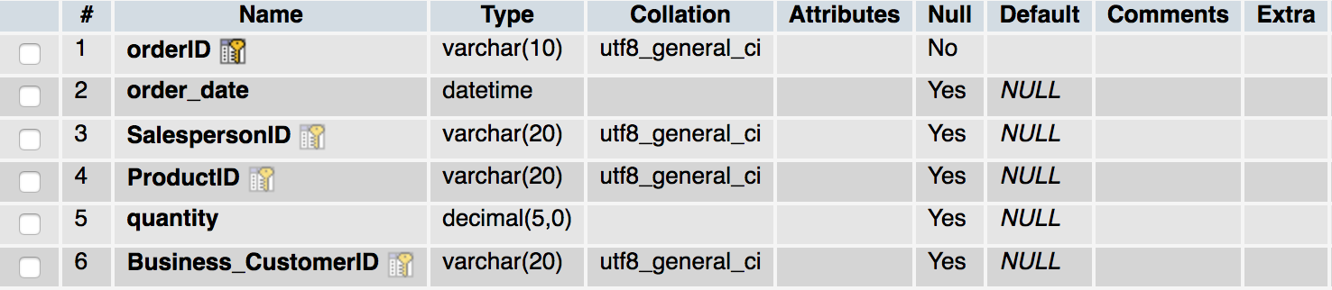

*Figure 4.5 Business_Transaction*

## 4.5 Home

Primary key of Home is HomeID.

FDs: HomeID→gender, HomeID→age, HomeID→marriage_status,

HomeID→incomes;

It is a BCNF.

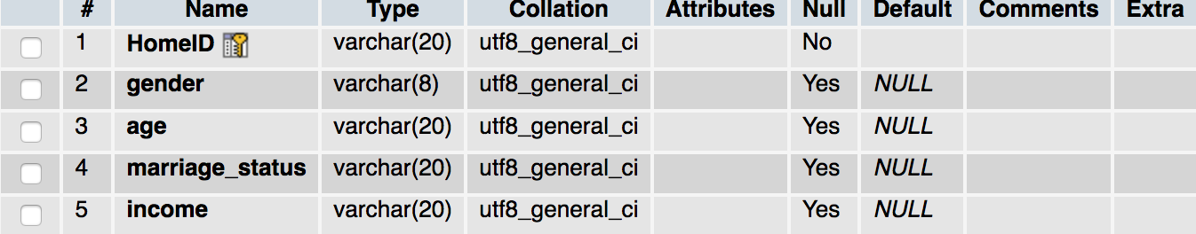

*Figure 4.6 Home*

## 4.6 Home_Customer

Primary key of Home_Customer is Home_Customer_ID.

Foreign key of Home_Customer are AddressID and HomeID.

FDs: Home_CustomerID→name, Home_CustomerID→AddressID, Home_CustomerID→HomeID, Home_CustomerID→password;

It is a BCNF.

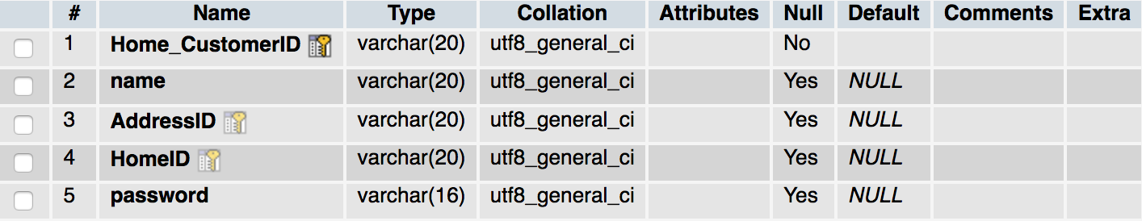

*Figure 4.7 Home_Customer*

## 4.7 Home_Transaction

Primary key of Home_Transaction is orderID.

The foreign key of Home_Transaction are SalespersonID, ProductID, Home_Customer_ID.

FDs: orderID→order_date, orderID→Salesperson, orderID→ProductID, orderID→quantity, orderID→Home_CustomerID;

It is a BCNF.

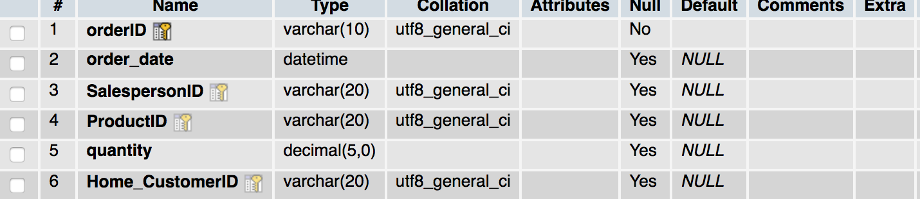

*Figure 4.8 Home_Transaction*

## 4.8 Product

Primary key of Product is ProductID.

FDs: ProductID→name, ProductID→inventory_amount, ProductID→price, ProductID→kind;

It is a BCNF.

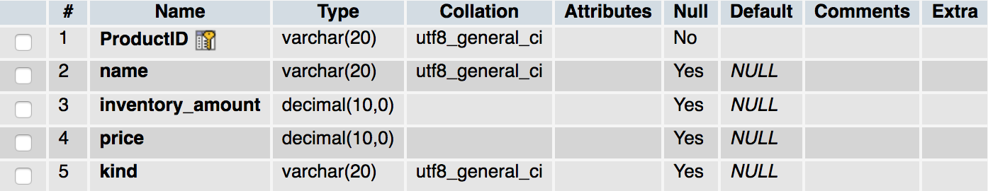

*Figure 4.9 Product*

## 4.9 Region

Primary key of Region is RegionID.

Foreign key of Region is region_managerID which references relation “Salesperson”.

FDs: RegionID→region_name, RegionID→region_managerID;

It is a BCNF.

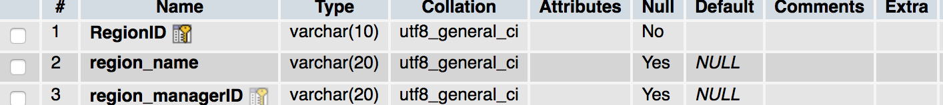

*Figure 4.10 Region*

## 4.10 Salesperson

Primary key of Salesperson is SalespersonID.

Foreign key of Salesperson are AddressID, StoreID.

FDs: SalespersonID→name, SalespersonID→AddressID, SalespersonID→_mail, SalespersonID→StoreID, SalespersonID→jobtittle, SalespersonID→salary;

It is a BCNF.

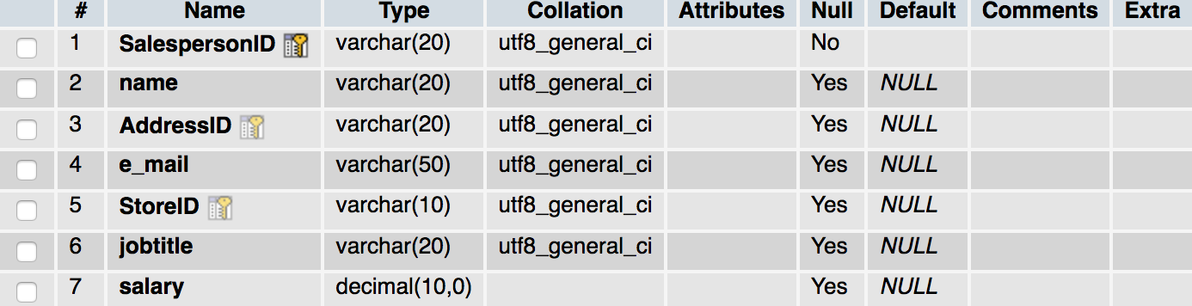

*Figure 4.11 Salesperson*

## 4.11 Store

Primary key of Store is StoreID.

The foreign key of Store are AddressID, RegionID and managerID.

FDs: StoreID→AddressID, StoreID→managerID, StoreID→Numberofsalespersons, StoreID→RegionID;

It is a BCNF.

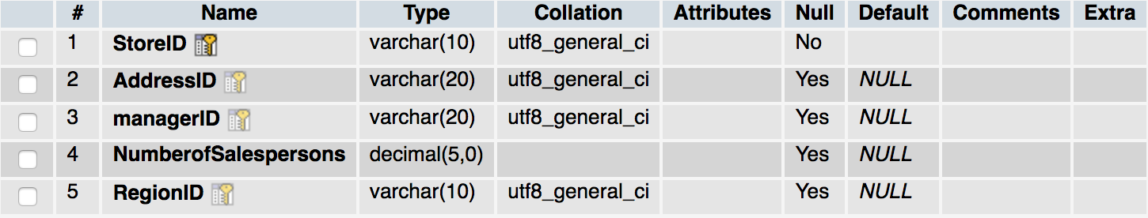

*Figure 4.12 Store*

## 4.12 Zipcode

Primary key of Zipcode is zipcode.

FDs: zipcode→city, zipcode→state;

It is a BCNF.

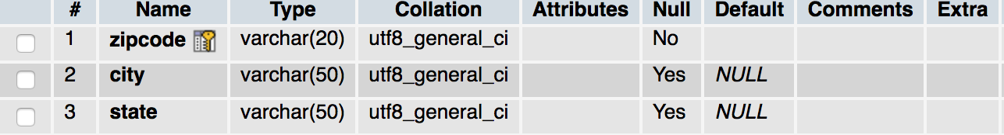

*Figure 4.13 Zipcode*

# 5. The DDL statements

(the FDs and Normal Forms justification have been discussed in part 4)

create table Zipcode

(zipcode varchar(20),

city varchar(50),

state varchar(50),

primary key (zipcode)

);

create table Address

(AddressID varchar(20),

street varchar(50),

zipcode varchar(20),

primary key (AddressID),

foreign key (zipcode) references Zipcode(zipcode)

on delete cascade

);

create table Business

(BusinessID varchar(20),

business_category varchar(50),

company_name varchar(20),

company_gross_annual_income varchar(20),

primary key (BusinessID)

);

create table Business_Customer

(Business_CustomerID varchar(20),

name varchar(20),

AddressID varchar(20),

BusinessID varchar(20),

password varchar(16),

primary key (Business_CustomerID),

foreign key (BusinessID) references Business(BusinessID)

on delete cascade,

foreign key (AddressID) references Address(AddressID)

on delete cascade

);

create table Home

(HomeID varchar(20),

gender varchar(8),

age varchar(6),

marriage_status varchar(20),

income varchar(20),

primary key (HomeID)

);

create table Home_Customer

(Home_CustomerID varchar(20),

name varchar(20),

AddressID varchar(20),

HomeID varchar(20),

password varchar(16),

primary key (Home_CustomerID),

foreign key (HomeID) references Home(HomeID)

on delete cascade,

foreign key (AddressID) references Address(AddressID)

on delete cascade

);

create table Product

(ProductID varchar(20),

name varchar(20),

inventory_amount numeric(10),

price numeric(10),

kind varchar(20),

primary key (ProductID)

);

create table Region

(RegionID varchar(10),

region_name varchar(20),

region_managerID varchar(20),

primary key (RegionID)

);

create table Store

(StoreID varchar(10),

AddressID varchar(20),

managerID varchar(20),

NumberofSalespersons numeric(5),

RegionID varchar(10),

primary key (StoreID),

foreign key (AddressID) references Address(AddressID)

on delete cascade,

foreign key (RegionID) references Region(RegionID)

on delete cascade

);

create table Salesperson

(SalespersonID varchar(20),

name varchar(20),

AddressID varchar(20),

e_mail varchar(50),

StoreID varchar(10),

jobtitle varchar(20),

salary numeric(10),

primary key (SalespersonID),

foreign key (AddressID) references Address(AddressID)

on delete cascade,

foreign key (StoreID) references Store(StoreID)

on delete cascade

);

create table Business_Transaction

(orderID varchar(10),

order_date datetime,

SalespersonID varchar(20),

ProductID varchar(20),

quantity numeric(5),

Business_CustomerID varchar(20),

primary key (orderID),

foreign key (SalespersonID) references Salesperson(SalespersonID)

on delete cascade,

foreign key (ProductID) references Product(ProductID)

on delete cascade,

foreign key (Business_CustomerID) references Business_Customer(Business_CustomerID)

on delete cascade

);

create table Home_Transaction

(orderID varchar(10),

order_date datetime,

SalespersonID varchar(20),

ProductID varchar(20),

quantity numeric(5),

Home_CustomerID varchar(20),

primary key (orderID),

foreign key (SalespersonID) references Salesperson(SalespersonID)

on delete cascade,

foreign key (ProductID) references Product(ProductID)

on delete cascade,

foreign key (Home_CustomerID) references Home_Customer(Home_CustomerID)

on delete cascade

);

alter table Store add constraint fk_store

foreign key (managerID) references Salesperson(SalespersonID)

on update cascade

on delete cascade;

alter table Region add constraint fk_region

foreign key (region_managerID) references Salesperson(SalespersonID)

on update cascade

on delete cascade;

# 6. Front-end and back-end design

Our team uses PhpStorm as a development tool to complete this project, because PhpStorm supports not only HTML5, CSS and JavaScript, but also PHP. It is an easily operating and powerful tool to develop any web projects with MySQL database.

## 6.1 Front-end design

Our team uses HTML5, CSS and JavaScript based on the Twitter Bootstrap framework to complete the front-end design. HTML5 is a markup language used for structuring and presenting content on the websites. CSS is a simple mechanism for adding style to Web documents. JavaScript is a high-level, dynamic, and interpreted programming language used for some actions on the websites. And Bootstrap is the most popular HTML, CSS and JavaScript framework for developing responsive projects on the websites. Bootstrap has got many nice-looking, user-friendly components and it is easy to develop.

## 6.2 Back-end design

Our team uses PHP to be the server-side scripting language and do most of the work of connecting the database, doing SQL queries and so on. PHP is one of the most powerful server-side language in the world, because it can be embedded in the HTML document, and can be run as soon as the HTML form be submitted and also has fast speed to deal with every request.

# 7. Overview of the system implementation

## 7.1 Customer Interfaces

### 7.1.1 Login

At the beginning of this project, users have to login to do further actions. In the Login UI, users have to enter their username and password, and choose their identity kind (Home Customer or Business Customer), then click “Sign in” for authentication.

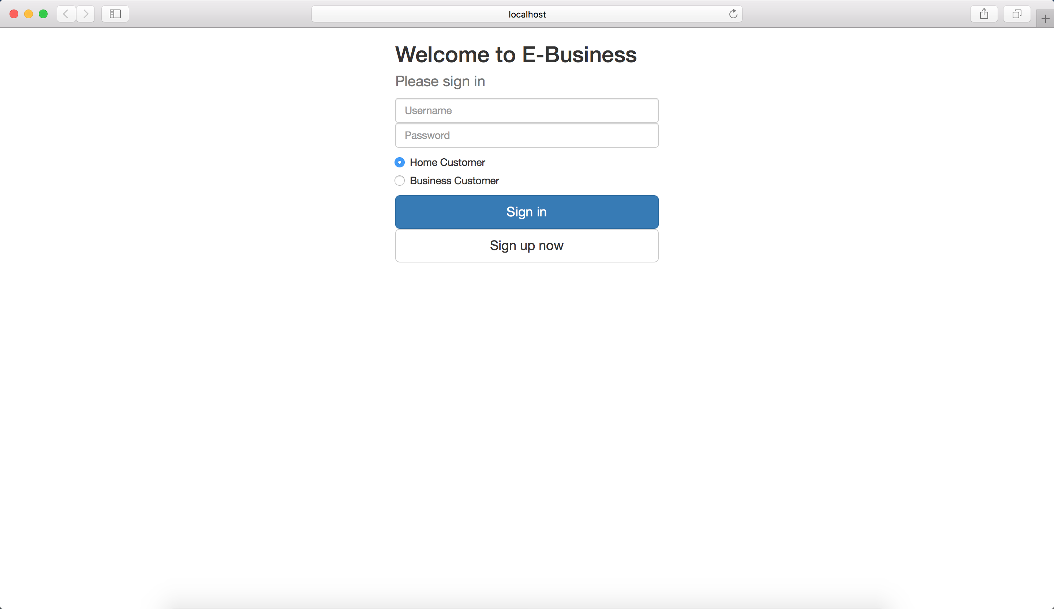

*Figure 7.1.1 Login interface*

### 7.1.2 Log-up

If new users come in, they can click “Sign up now” in the first page to register into this web product. In the log-up page, users are supposed to enter their username, password, reenter-password, their address information (street, zip code, city, state). If the user is a home customer, she/he is supposed to click the radio button “I am a Home Customer”, and enter her/his age, gender, marriage status and income. If the user is a business customer, she/he is supposed to click the radio button “I am a Business Customer”, and enter her/his company name, choose the company category, and enter the company gross annual income.

When the users finish entering these information, they should click “Sign up” button to complete the registration.

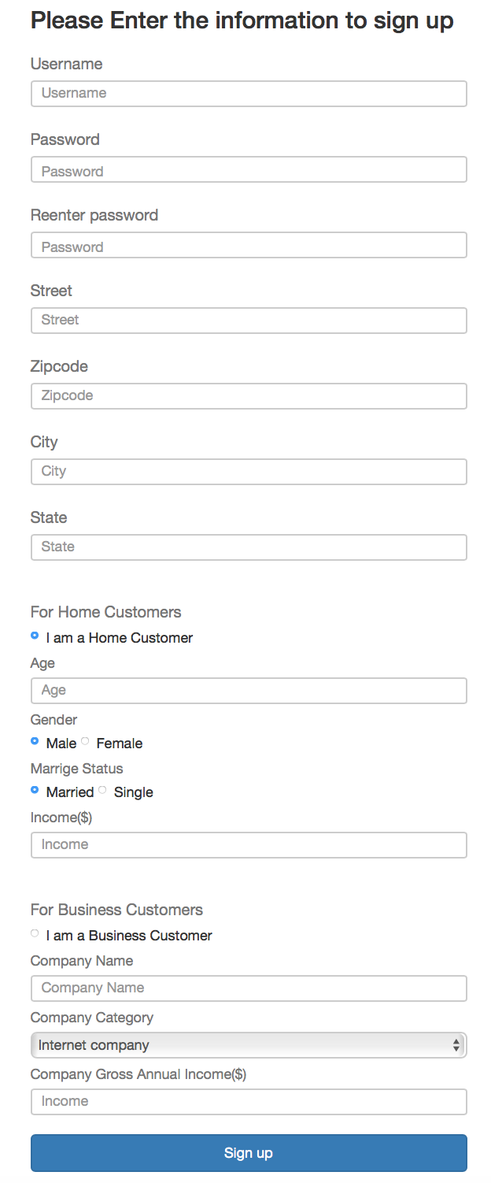

*Figure 7.1.2 Log-up interface*

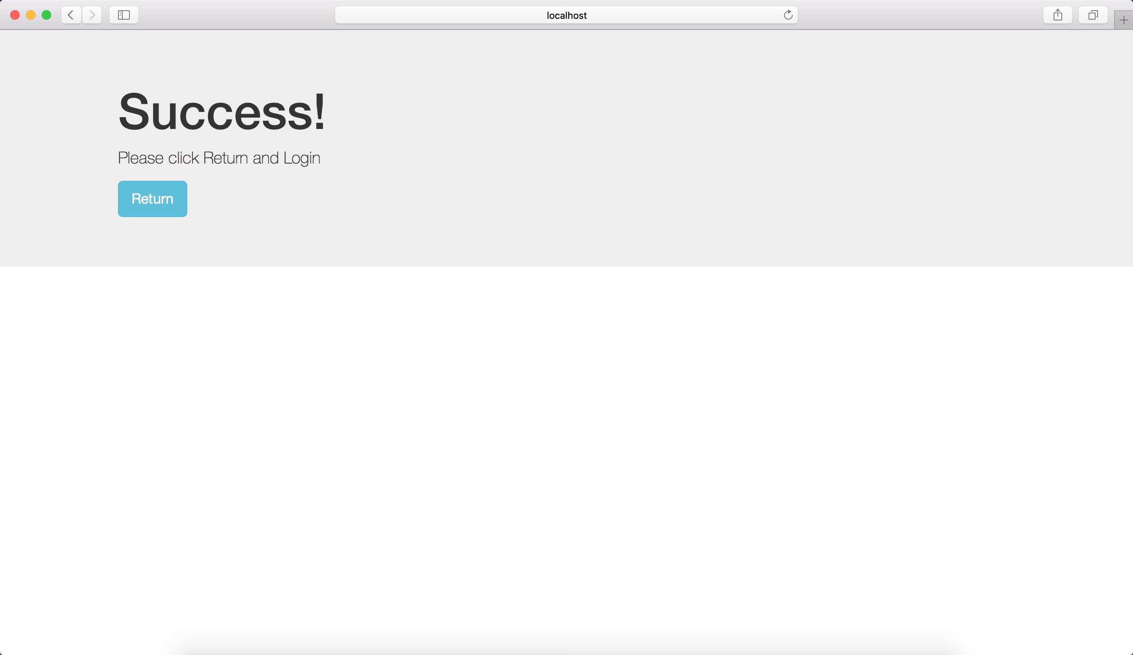

*Figure 7.1.3 Log-up success interface*

### 7.1.3 Region Choosing

When users successfully login the system, they have to firstly choose the region where they want to buy products.

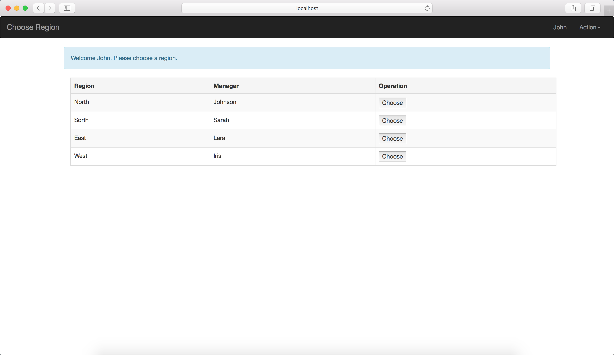

*Figure 7.1.4 Region Choosing interface*

### 7.1.4 Store and Salesperson Choosing

After choosing the region, customers have to choose their favorite store and corresponding salesperson. If they want to change the region they chose, they can click the “change” link to return and choose another region.

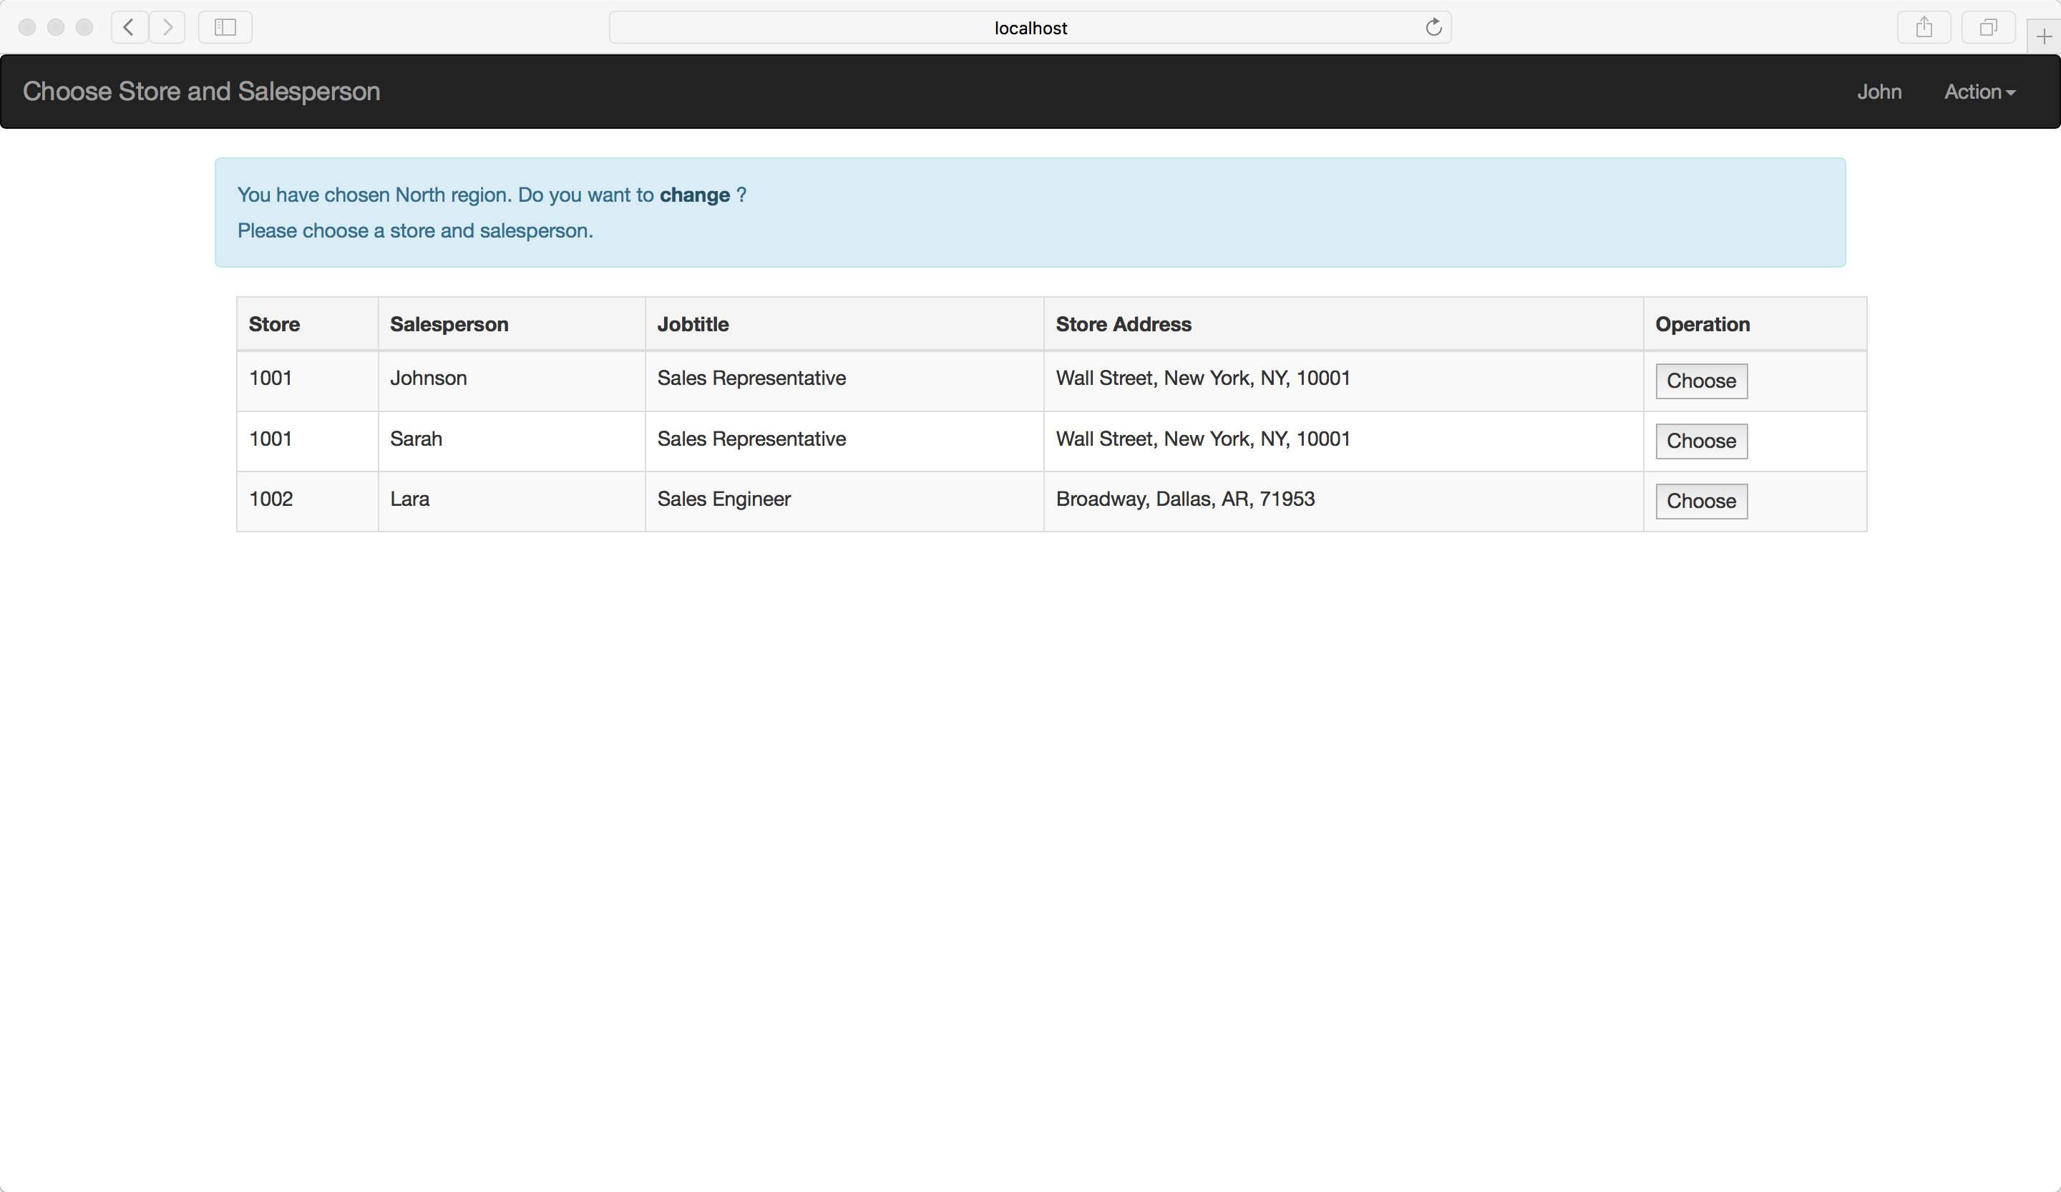

*Figure 7.1.5 Store and Salesperson Choosing interface*

### 7.1.5 Browsing Interface

After choosing the store and salesperson, users can browse all the products being selling. Users can see the product’s number, name, inventory amount, price and also can choose the quantity to buy, and with simply clicking the “Buy” button, they can have the products they like.

Besides, in top of this page, customers can choose a specific product category or search the name of some products, and also see the statistic based on all the finished transaction. Finally, if the user wants to leave, they can click the “Action” button, and click “log out” option to log out.

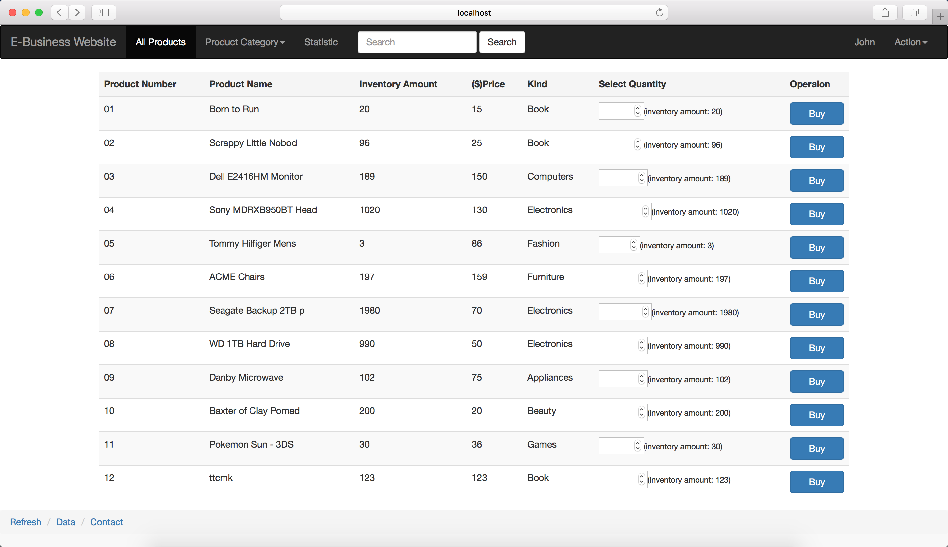

*Figure 7.1.6 Browsing interface*

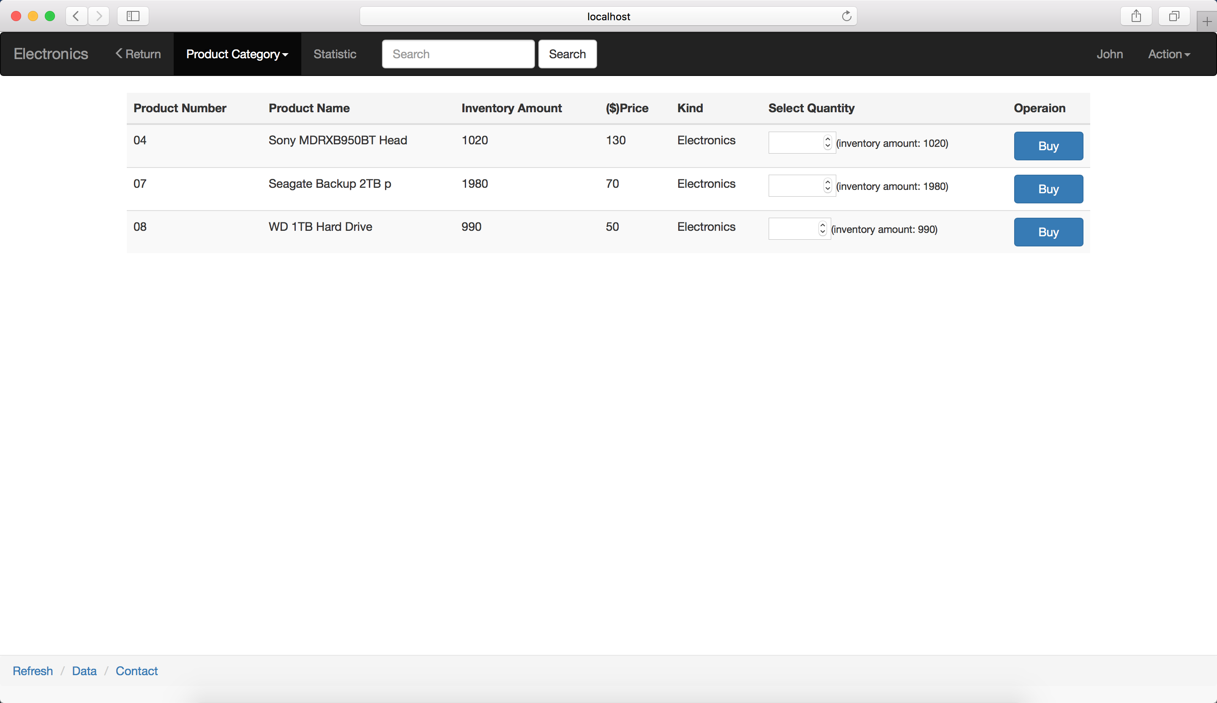

*Figure 7.1.7 Choose one category*

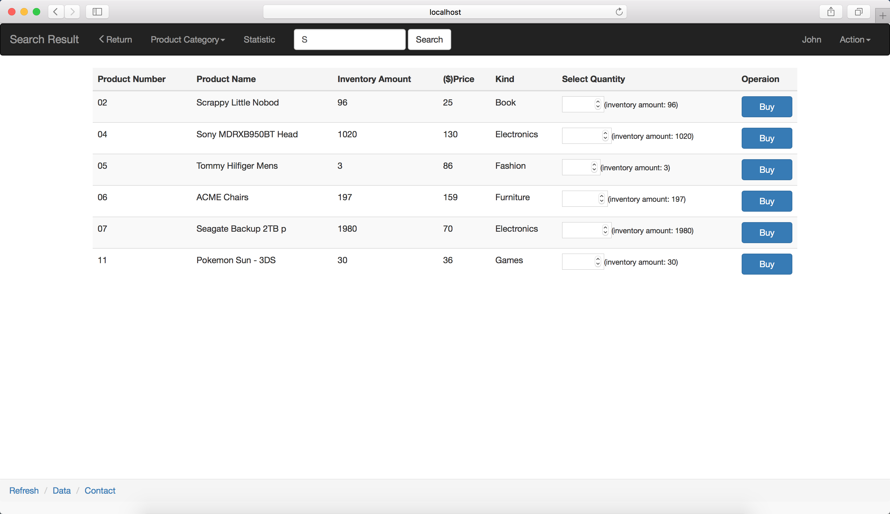

*Figure 7.1.8 Search for “S”*

### 7.1.6 Transaction details

When customers successfully make transactions, the system will show them the transaction details such as order name, order quantity and total amount of money to be paid. Then the customer can click “Continue Shopping” to return to the browsing page and choose other products.

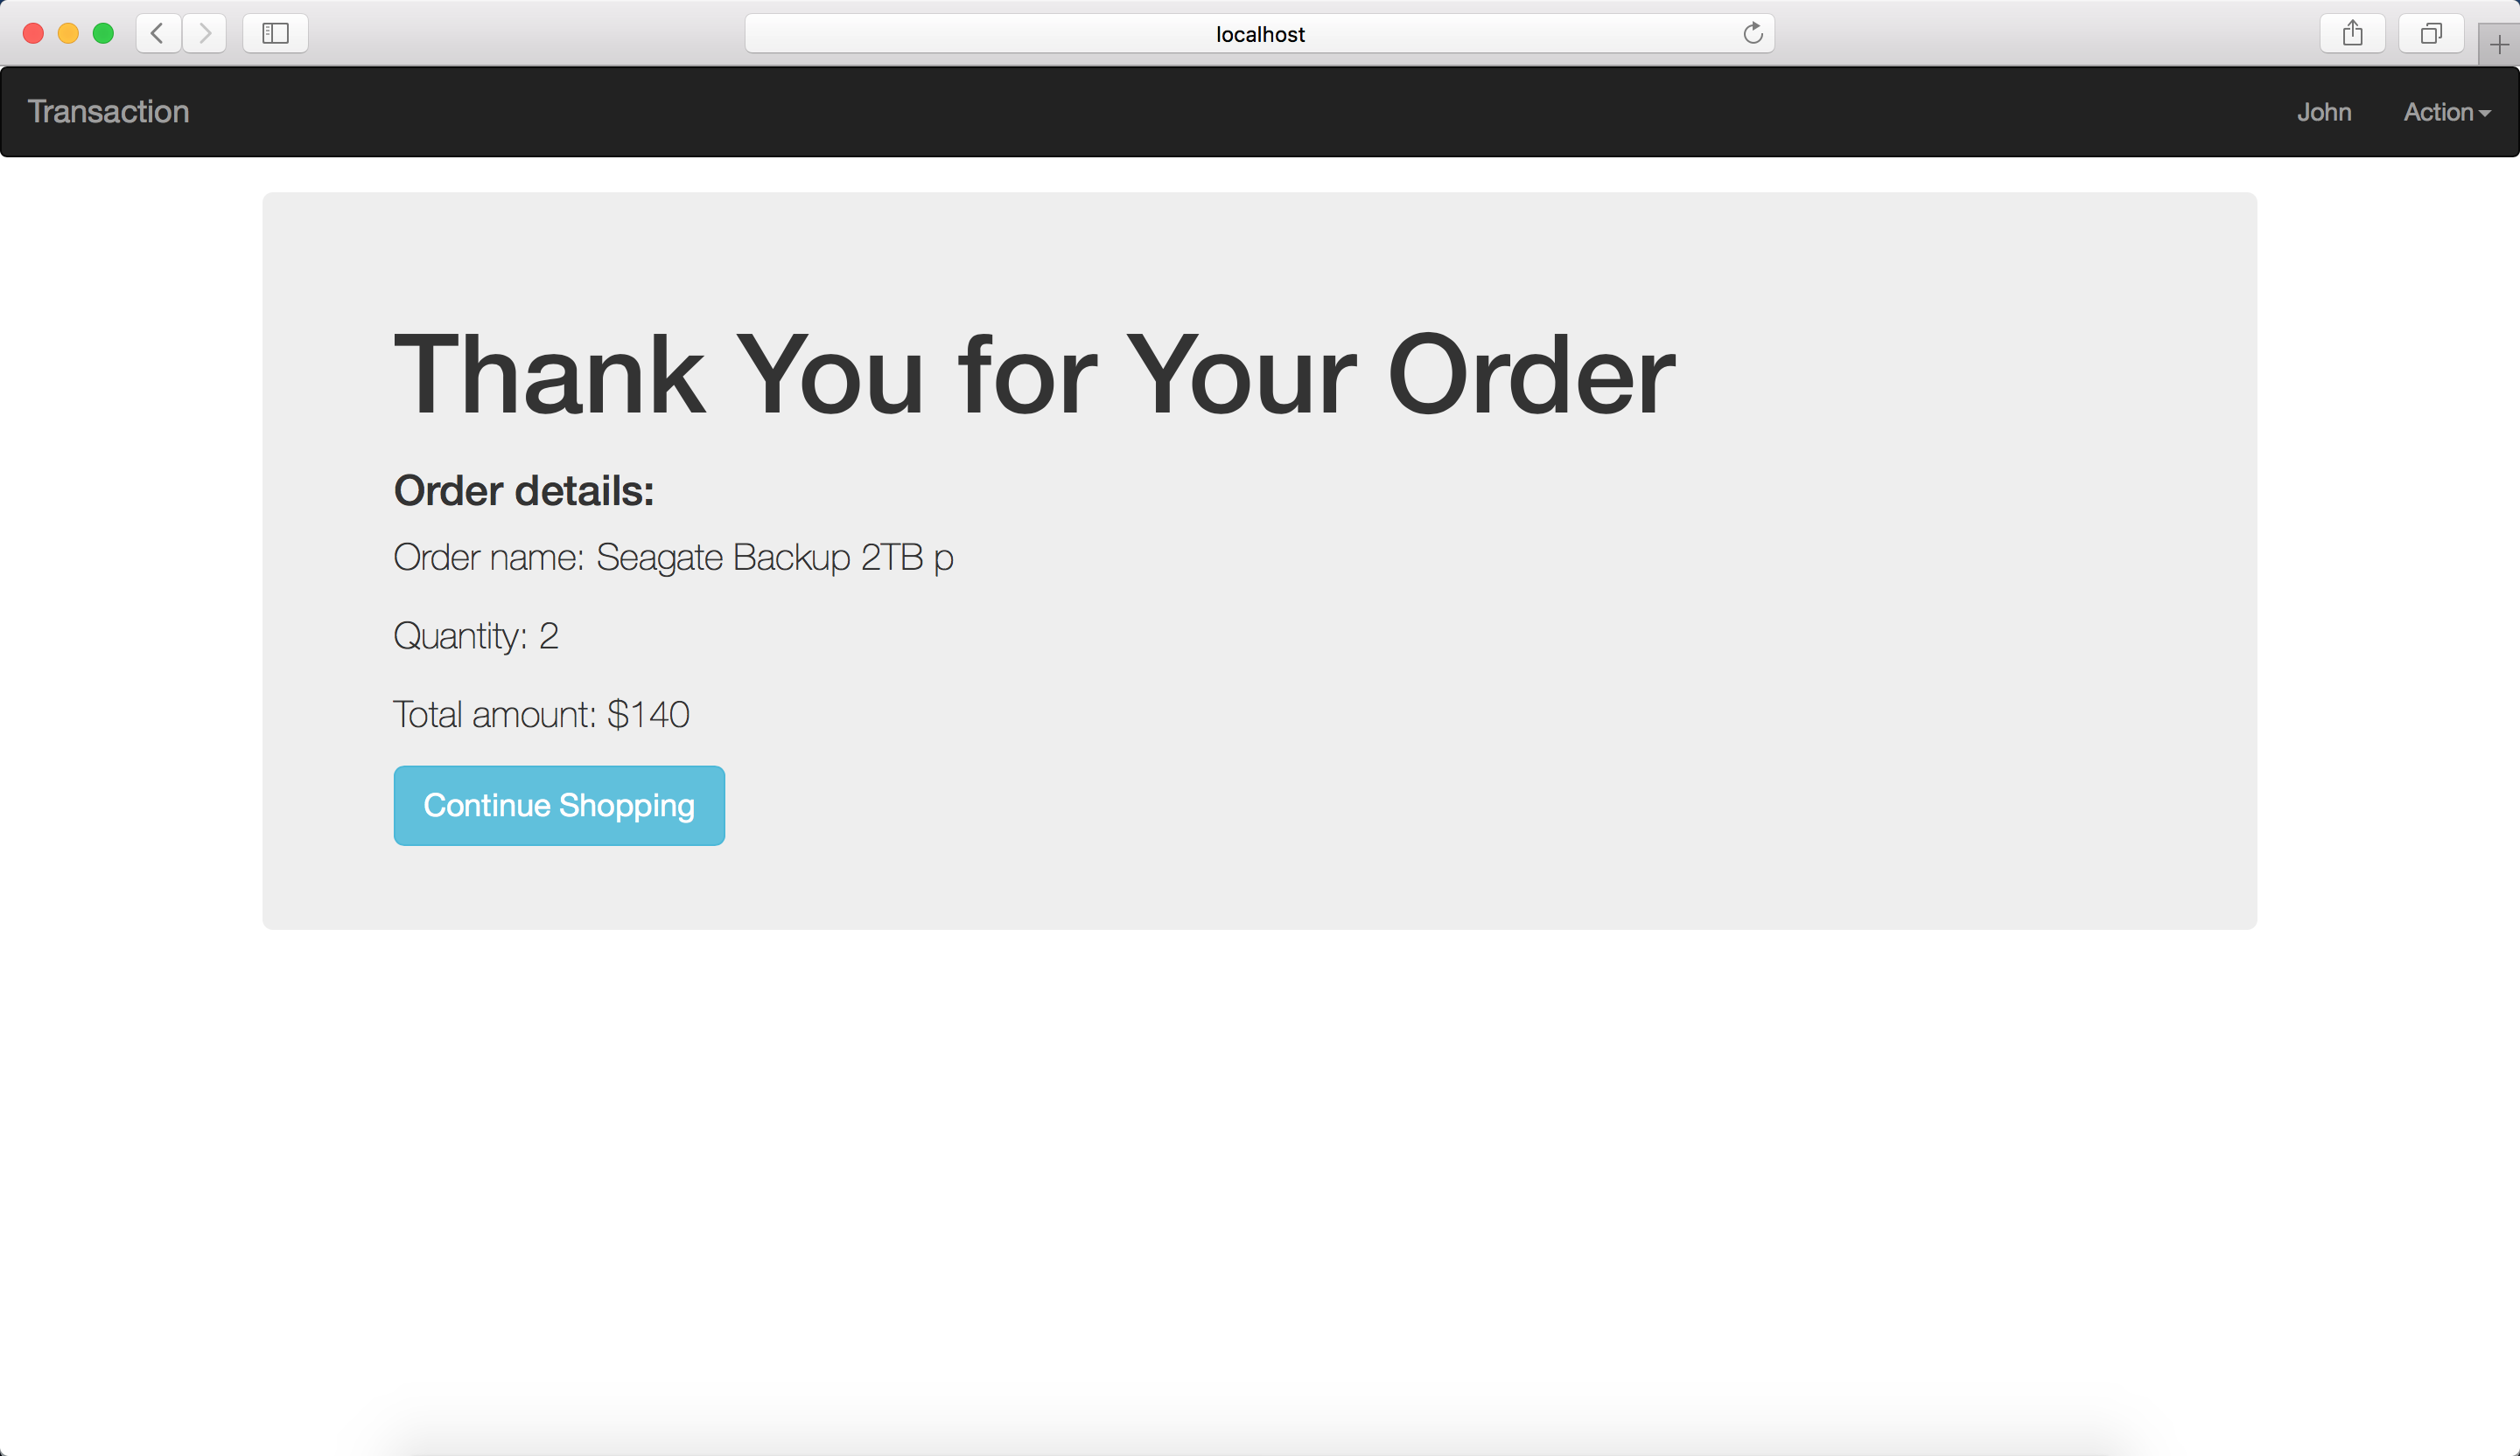

*Figure 7.1.9 Transaction details interface*

### 7.1.7 View Past Orders

Customer can click “View Past Orders” in the “Action” dropdown box and view her/his purchase history.

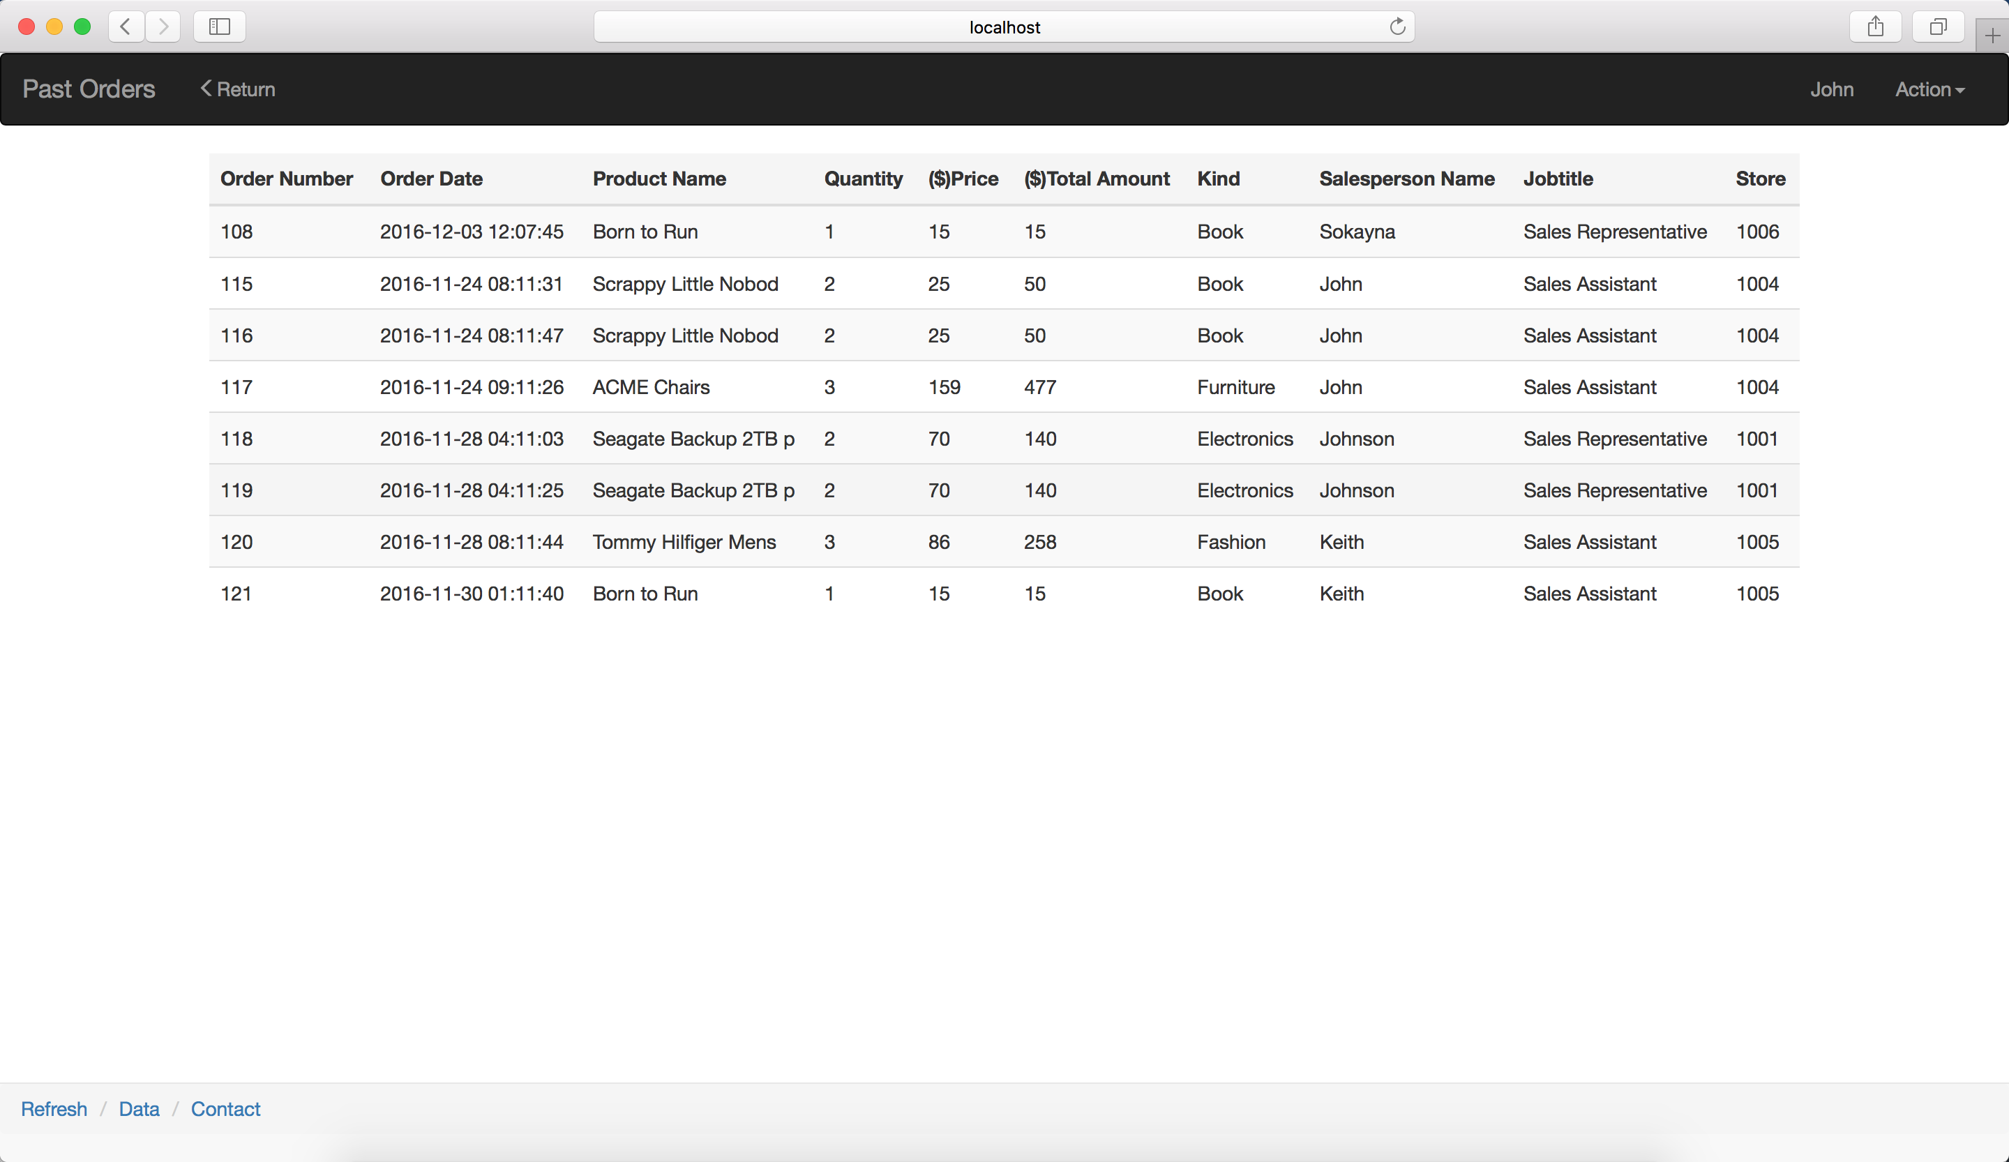

*Figure 7.1.10 View past orders*

### 7.1.8 Statistic of the Shop

In this page, there are two main part, one for information based on home customers’ transactions, while another one showing the information based on business customers’ transactions. In this way, everyone can figure out which product, product kind or region is most popular for home customers and business customers.

In every main part, people can see the profit ranking of individual product, profit ranking of product kind and sales volume ranking of region. And in the first part, people can click “View the Buyer Ranking” to see the quantity ranking of customers given one product.

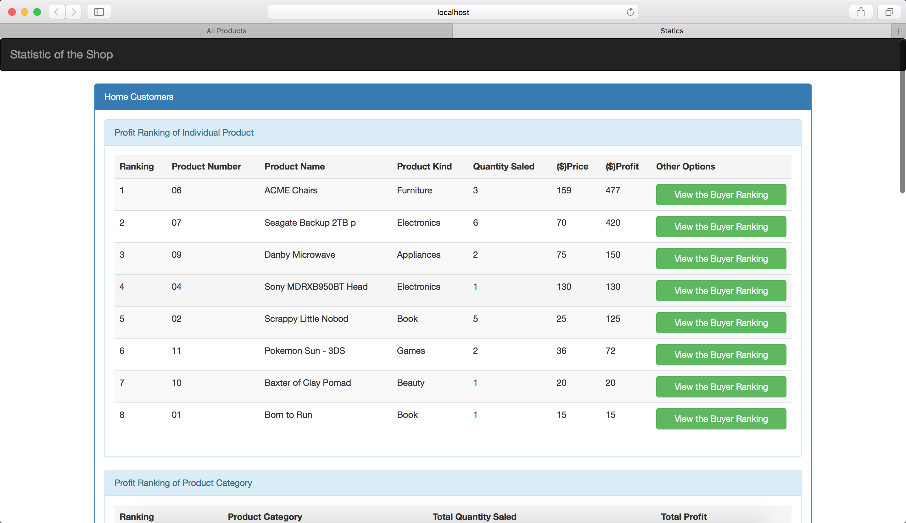

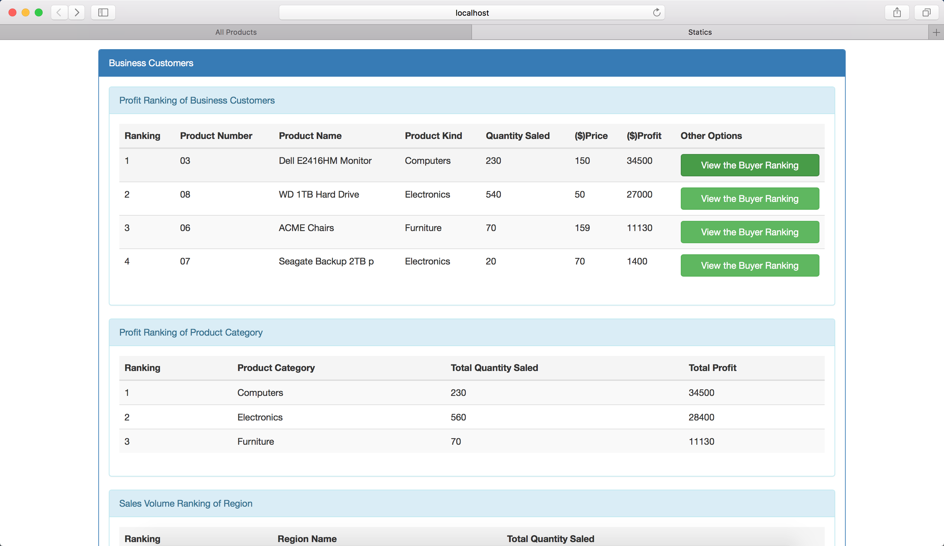

*Figure 7.1.11 Statistic of the Shop*

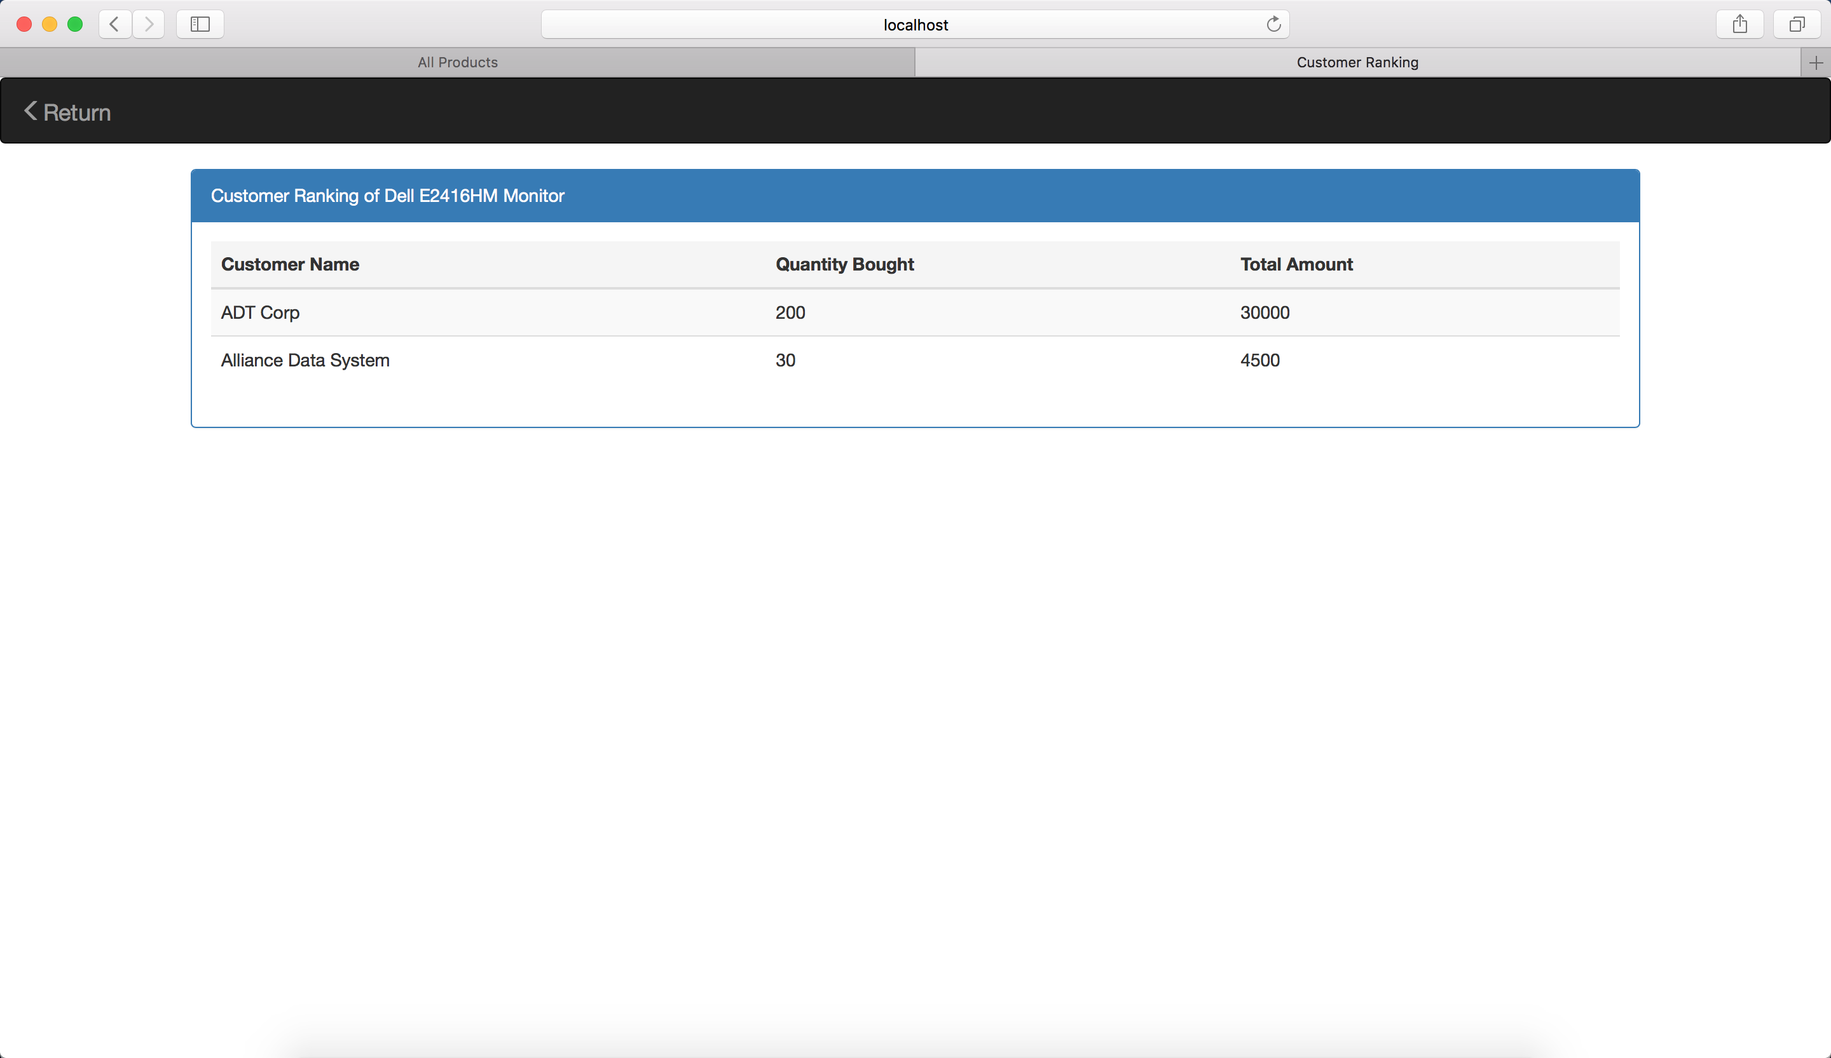

*Figure 7.1.12 Customer Ranking of one product*

## 7.2 Administrator Interfaces

In the Administrator page, the administrator can add new product, modify existing products or delete products.

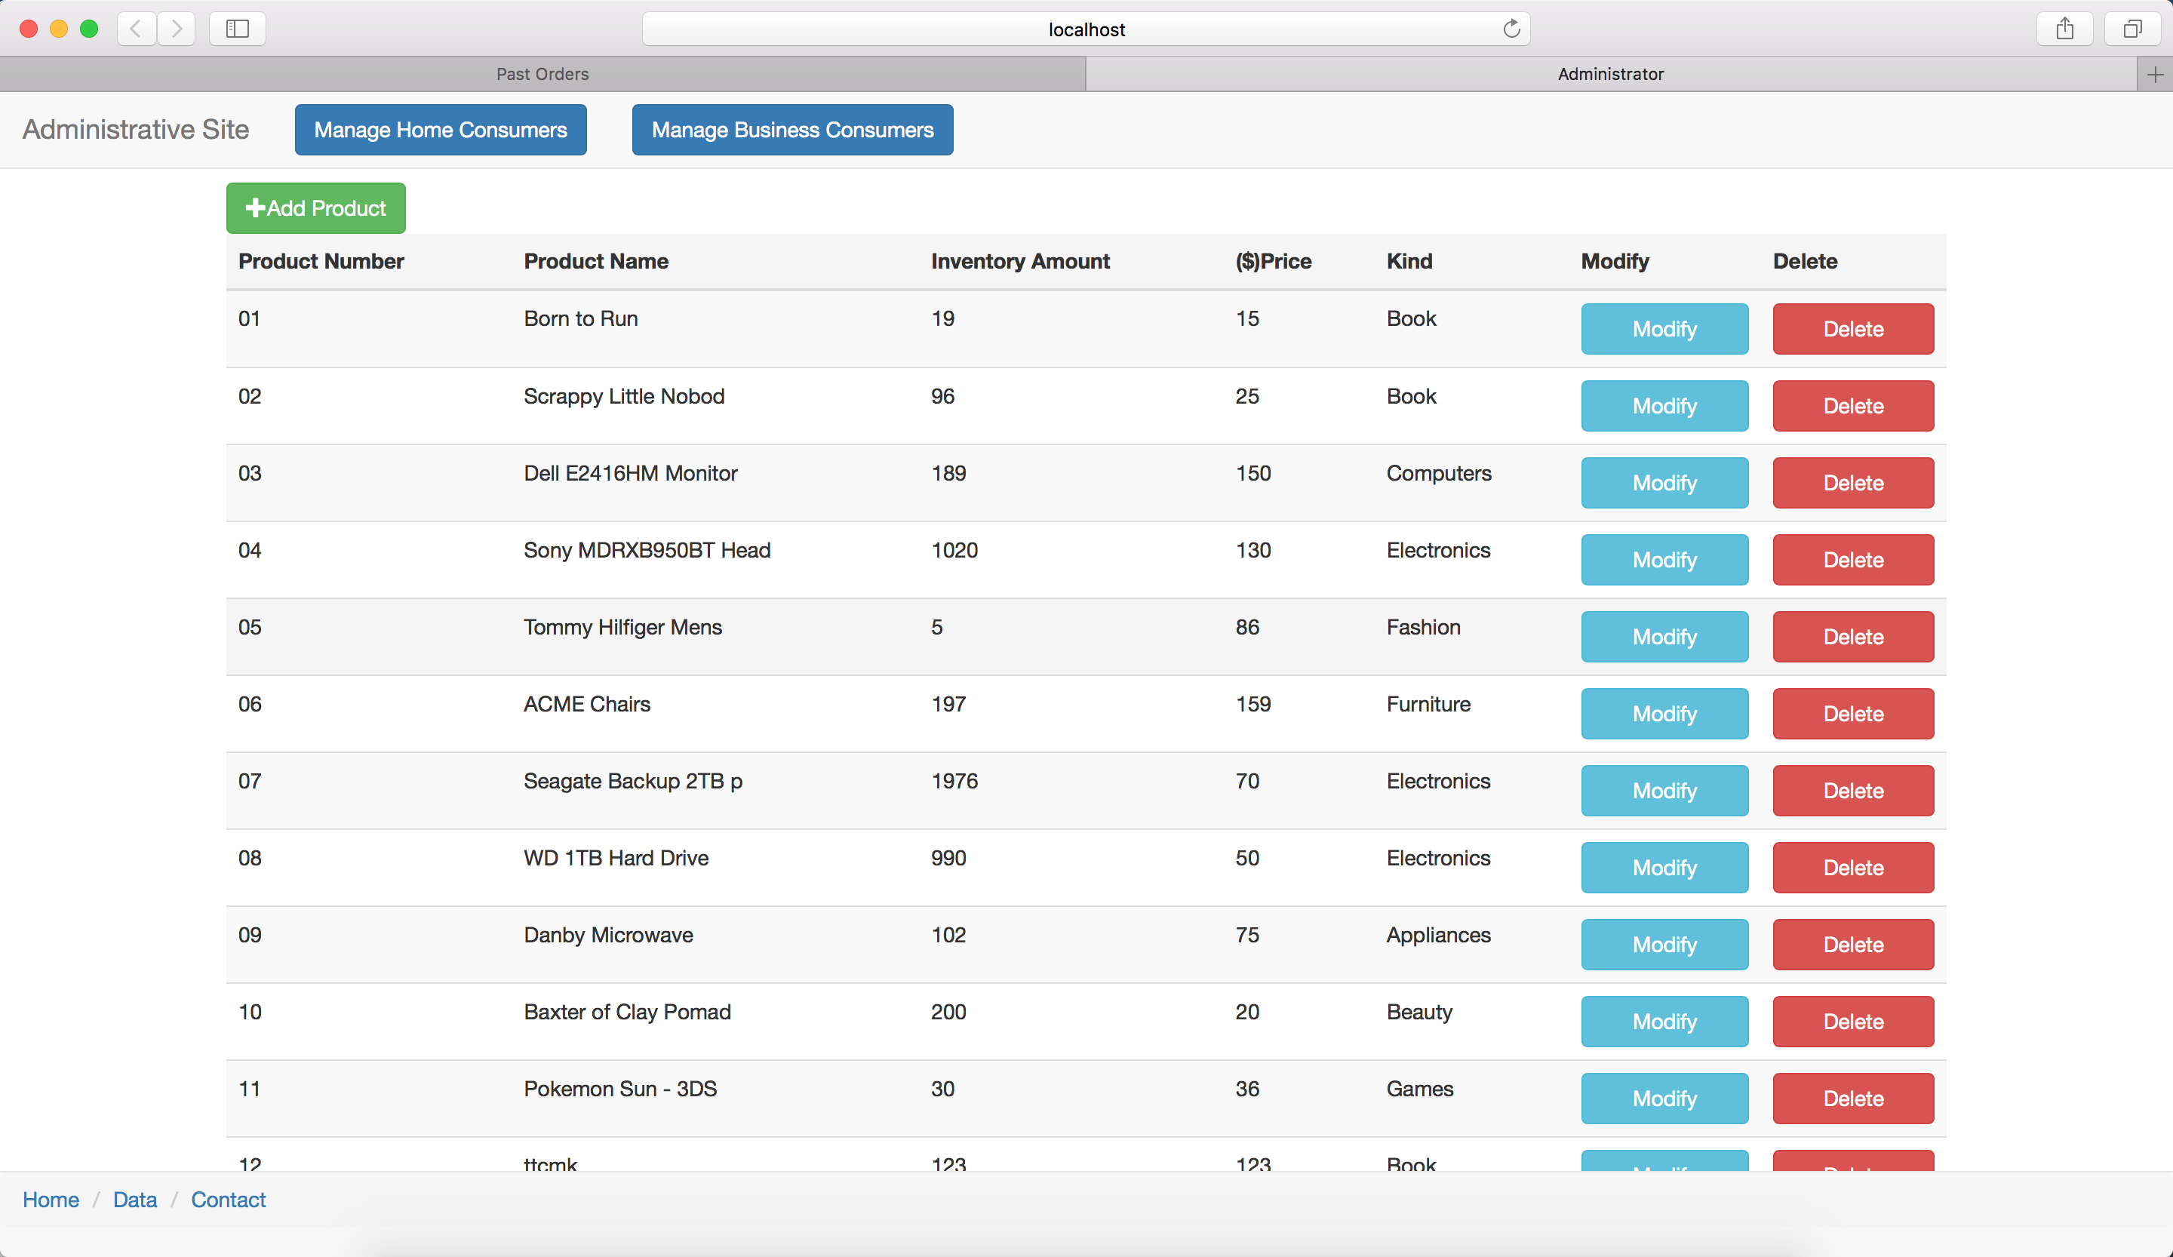

*Figure 7.2.1 Administrator interface*

### 7.2.1 Add products

When administrator clicks “Add Product” button, she/he will go to another page where she/he can enter the information of the product to be added. Then by clicking “Submit” button, the product will be added to the database if there does not exist a same product.

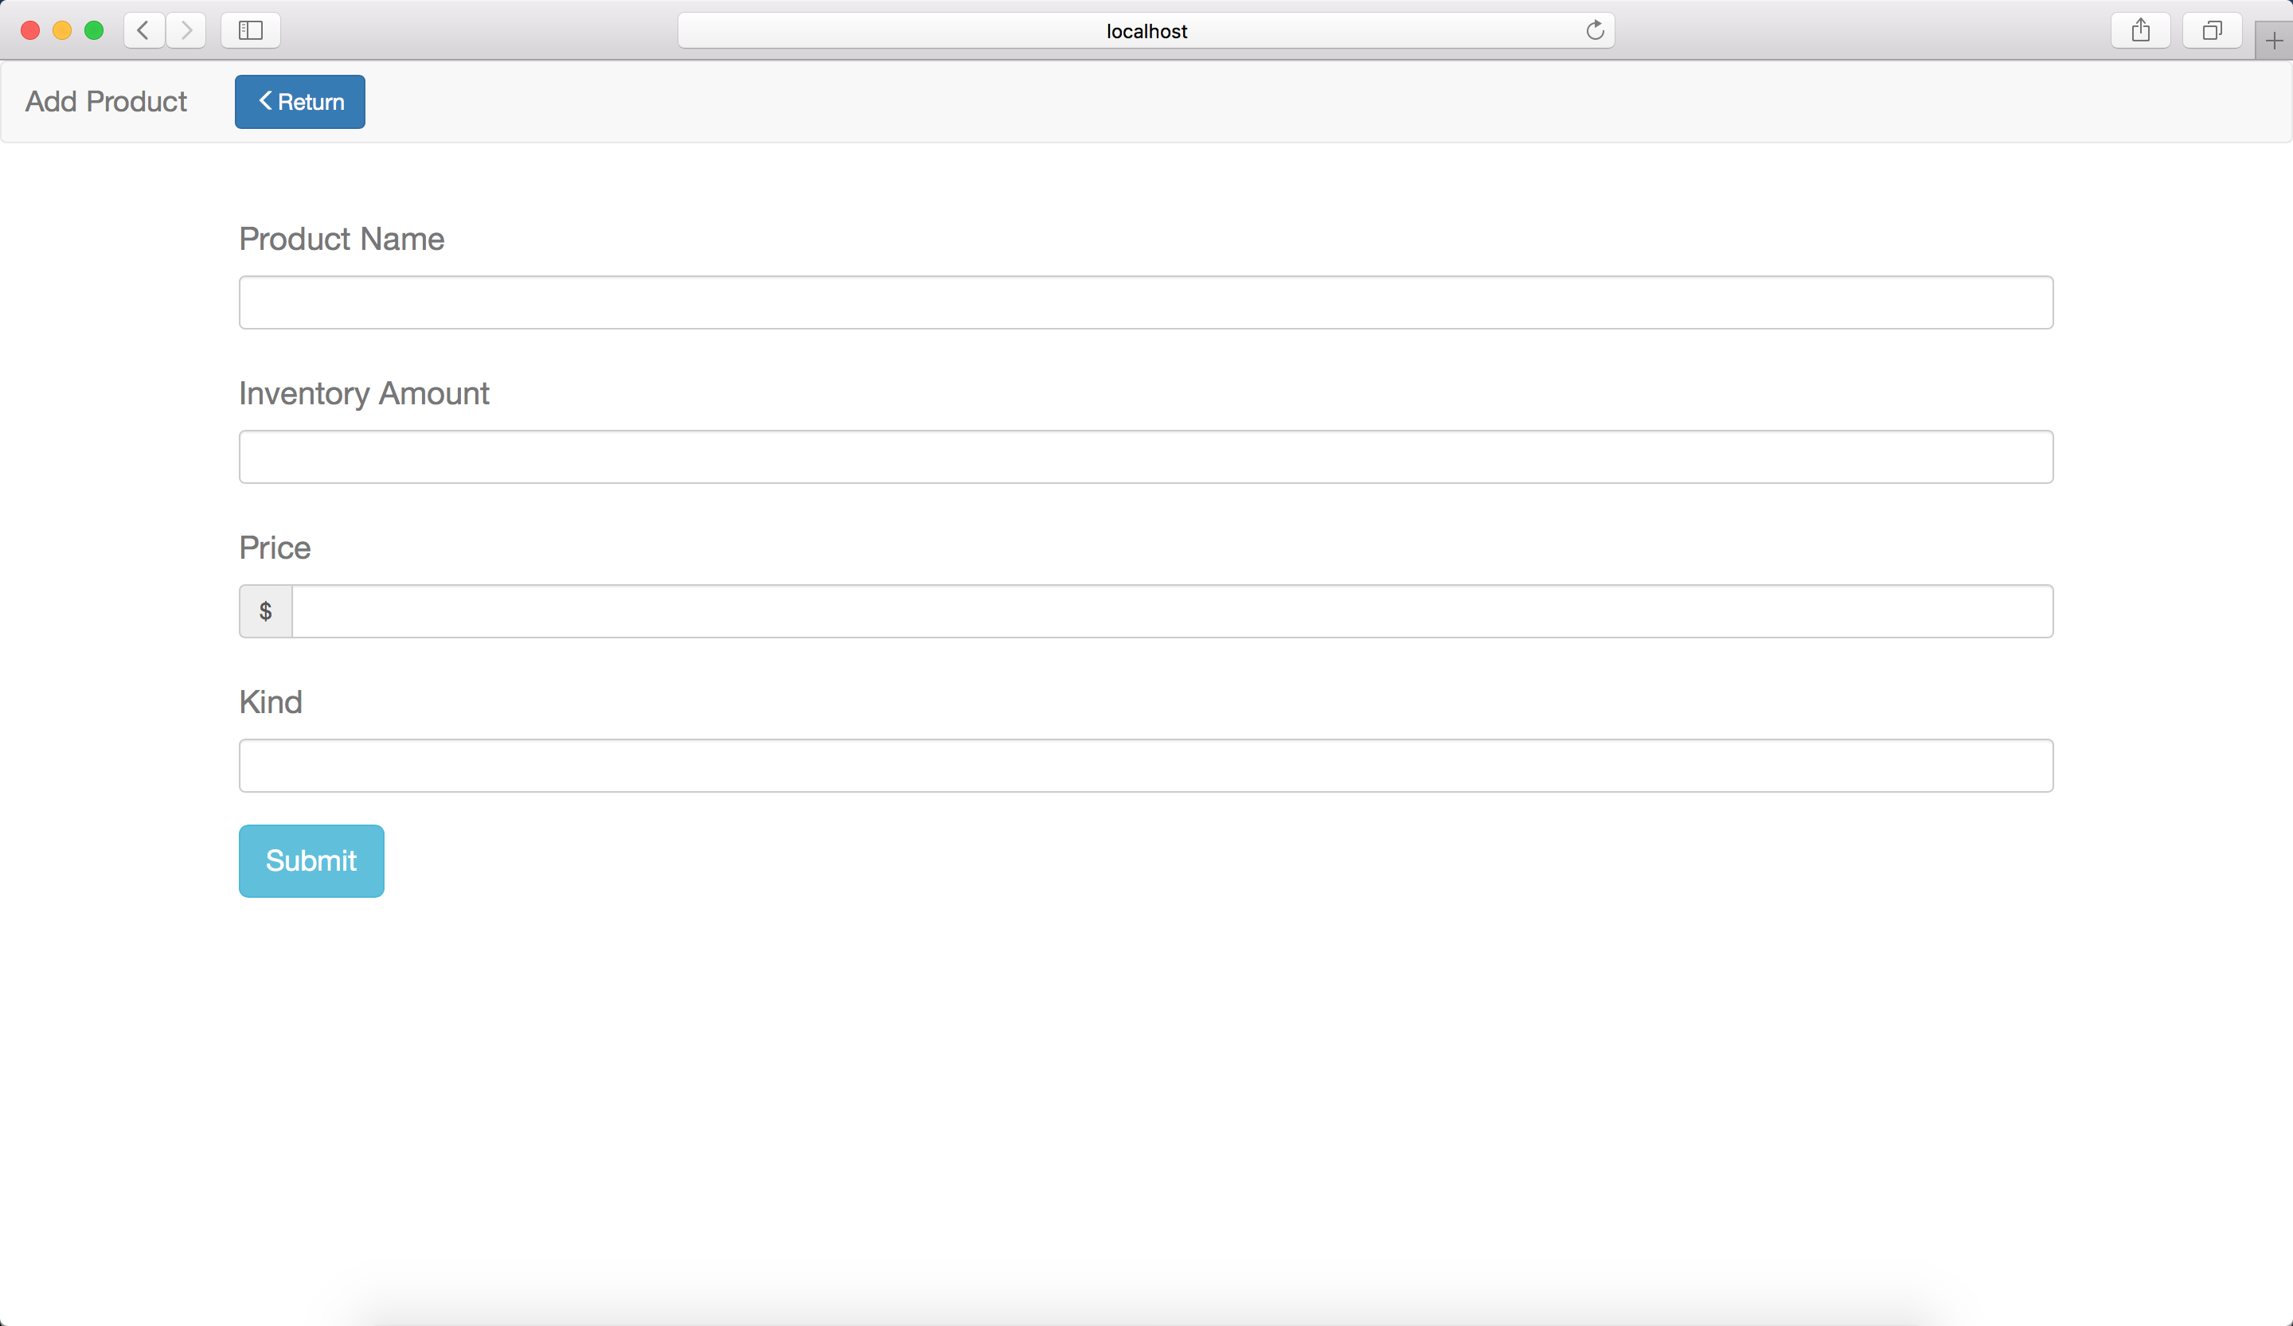

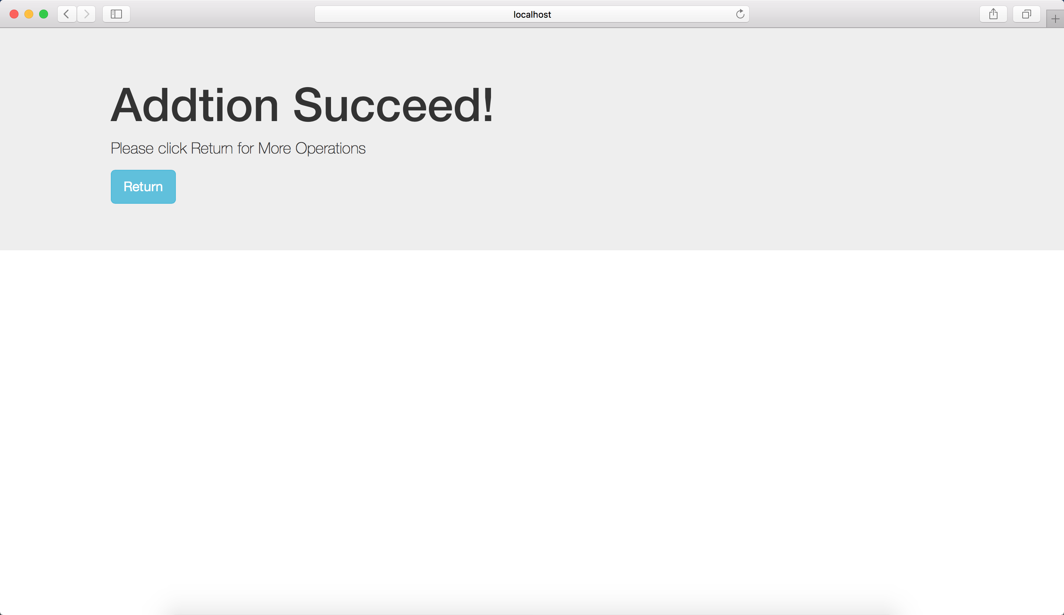

*Figure 7.2.2 Add Product interface*

### ­7.2.2 Modify products

When administrator clicks “Modify” button, she/he will go to another page where she/he can modify any information about one product except the product number. Then by clicking “Modify” button to ensure the modification.

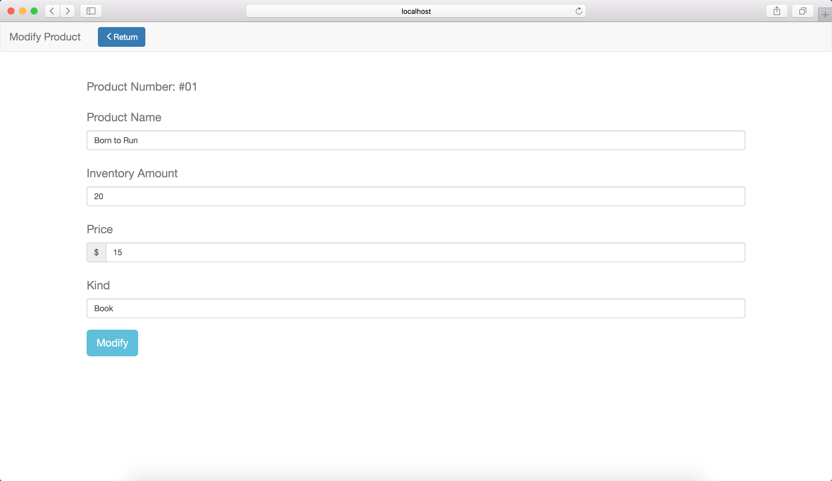

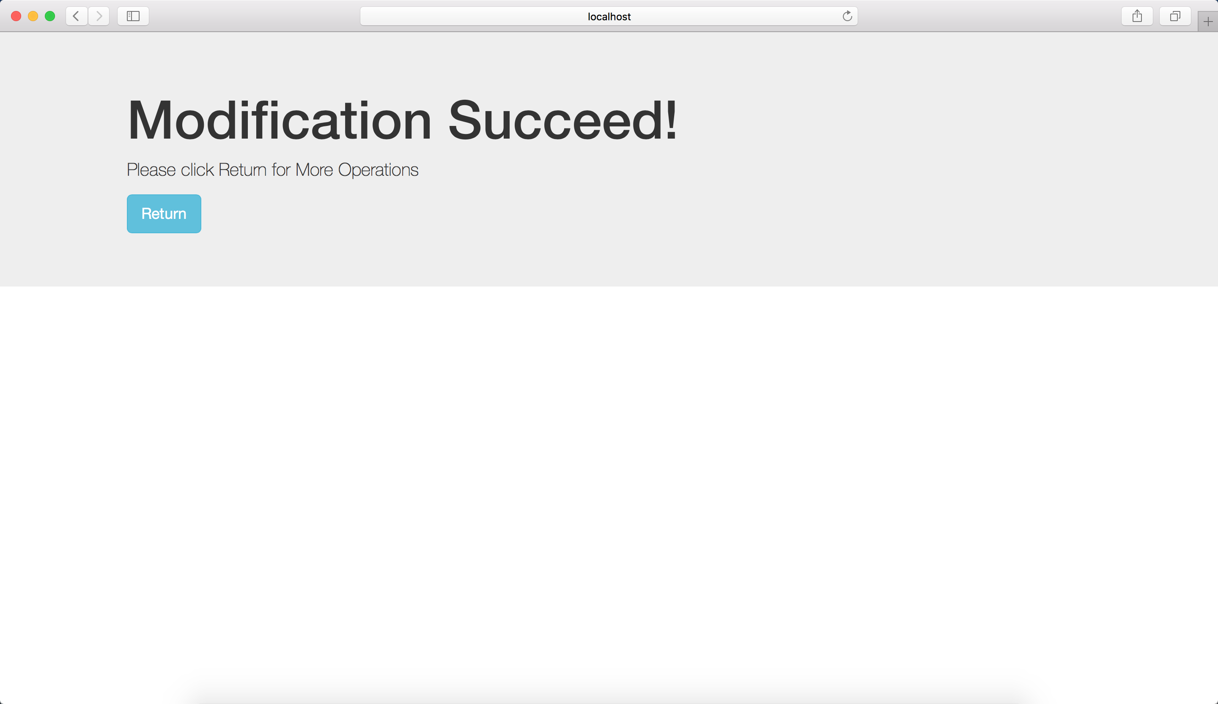

*Figure 7.2.3 Modification interface*

### 7.2.3 Delete products

When the administrator clicks “Delete” button, the system will confirm this request with the administrator. If she/he clicks “Confirm”, the product will be removed from the database. If she/he clicks “Cancel”, the system will not remove this product.

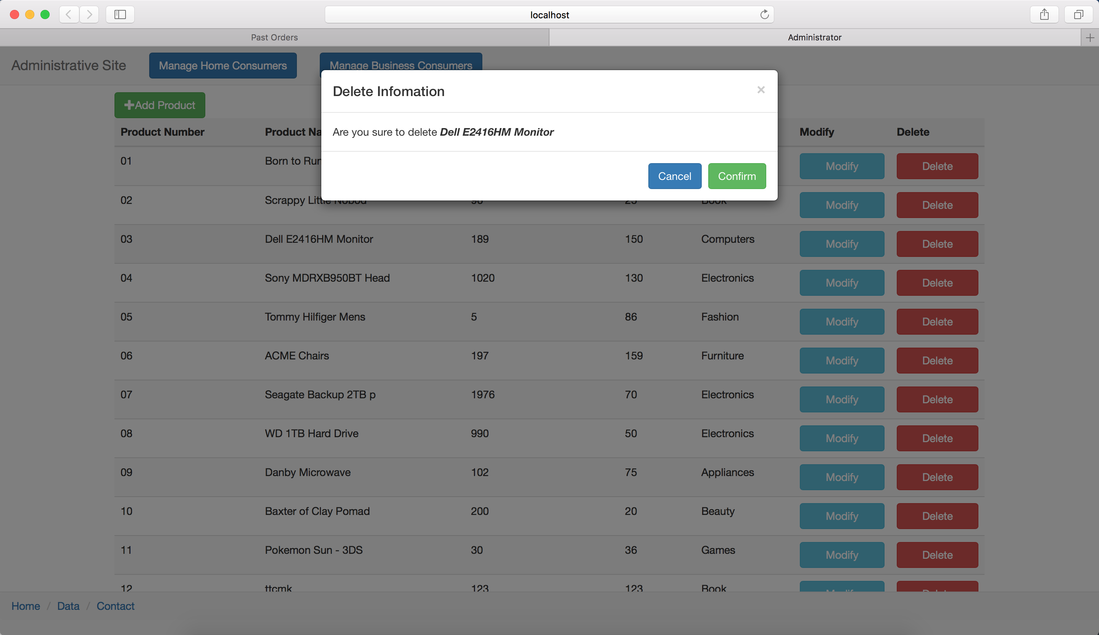

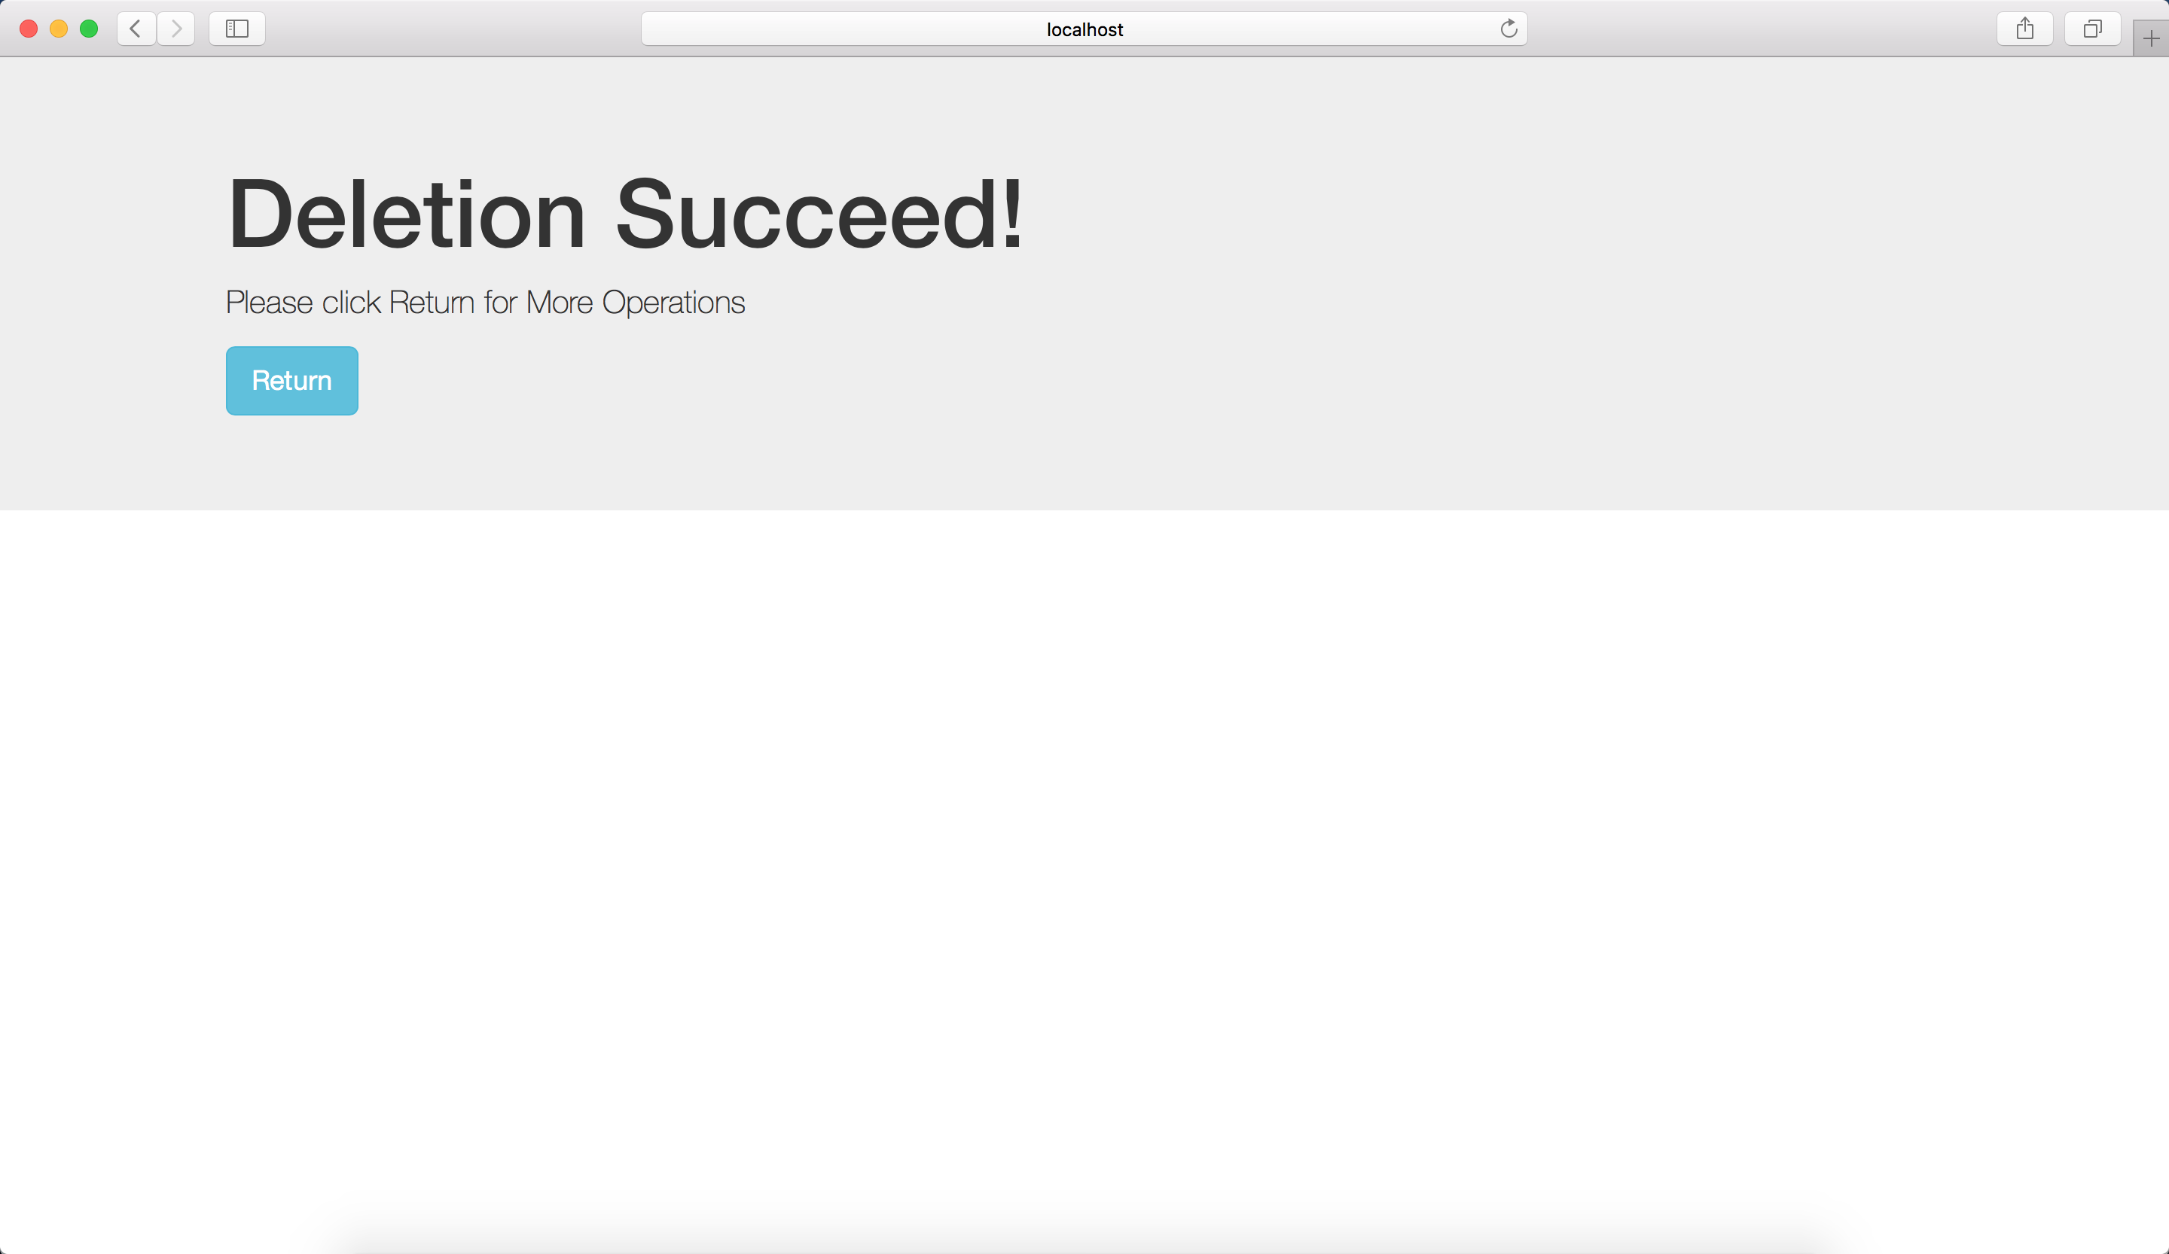

*Figure 7.2.4 Deletion interface*

### 7.2.4 Manage Customers

Administrator can click “Manage Home Customers” or “Manage Business Customers” button on the top of the Administrative site to manage home customers or business customers.

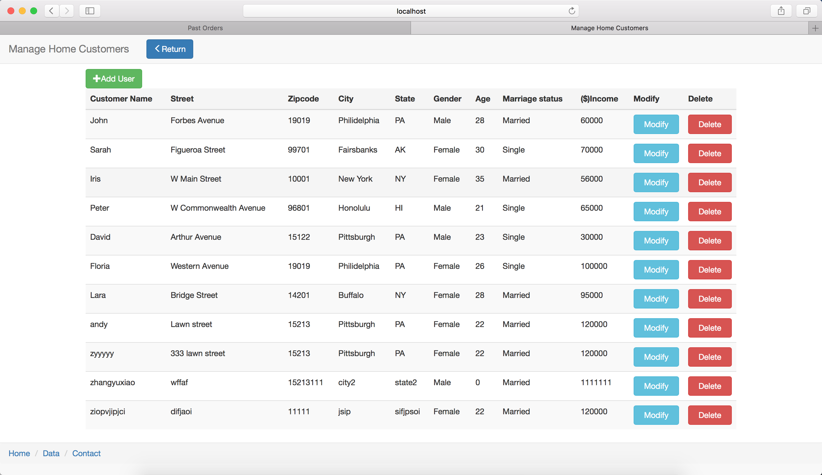

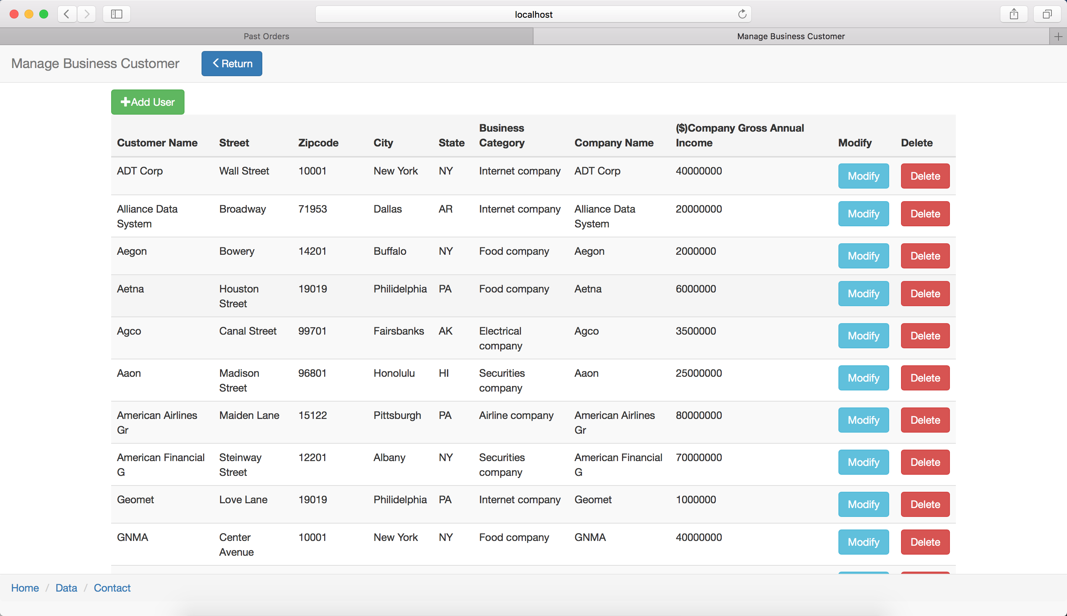

*Figure7.2.5 Manage Customers*

In each page, administrator can add, modify and delete every single customer.

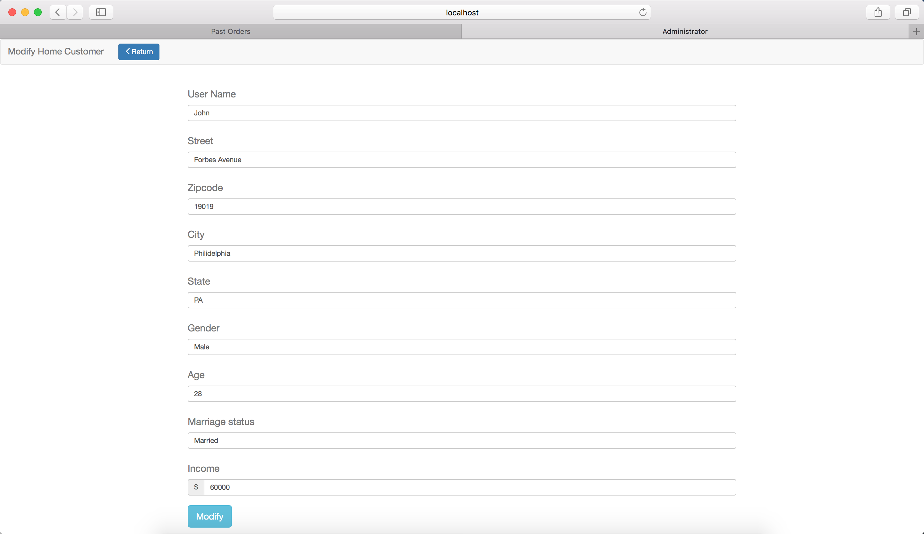

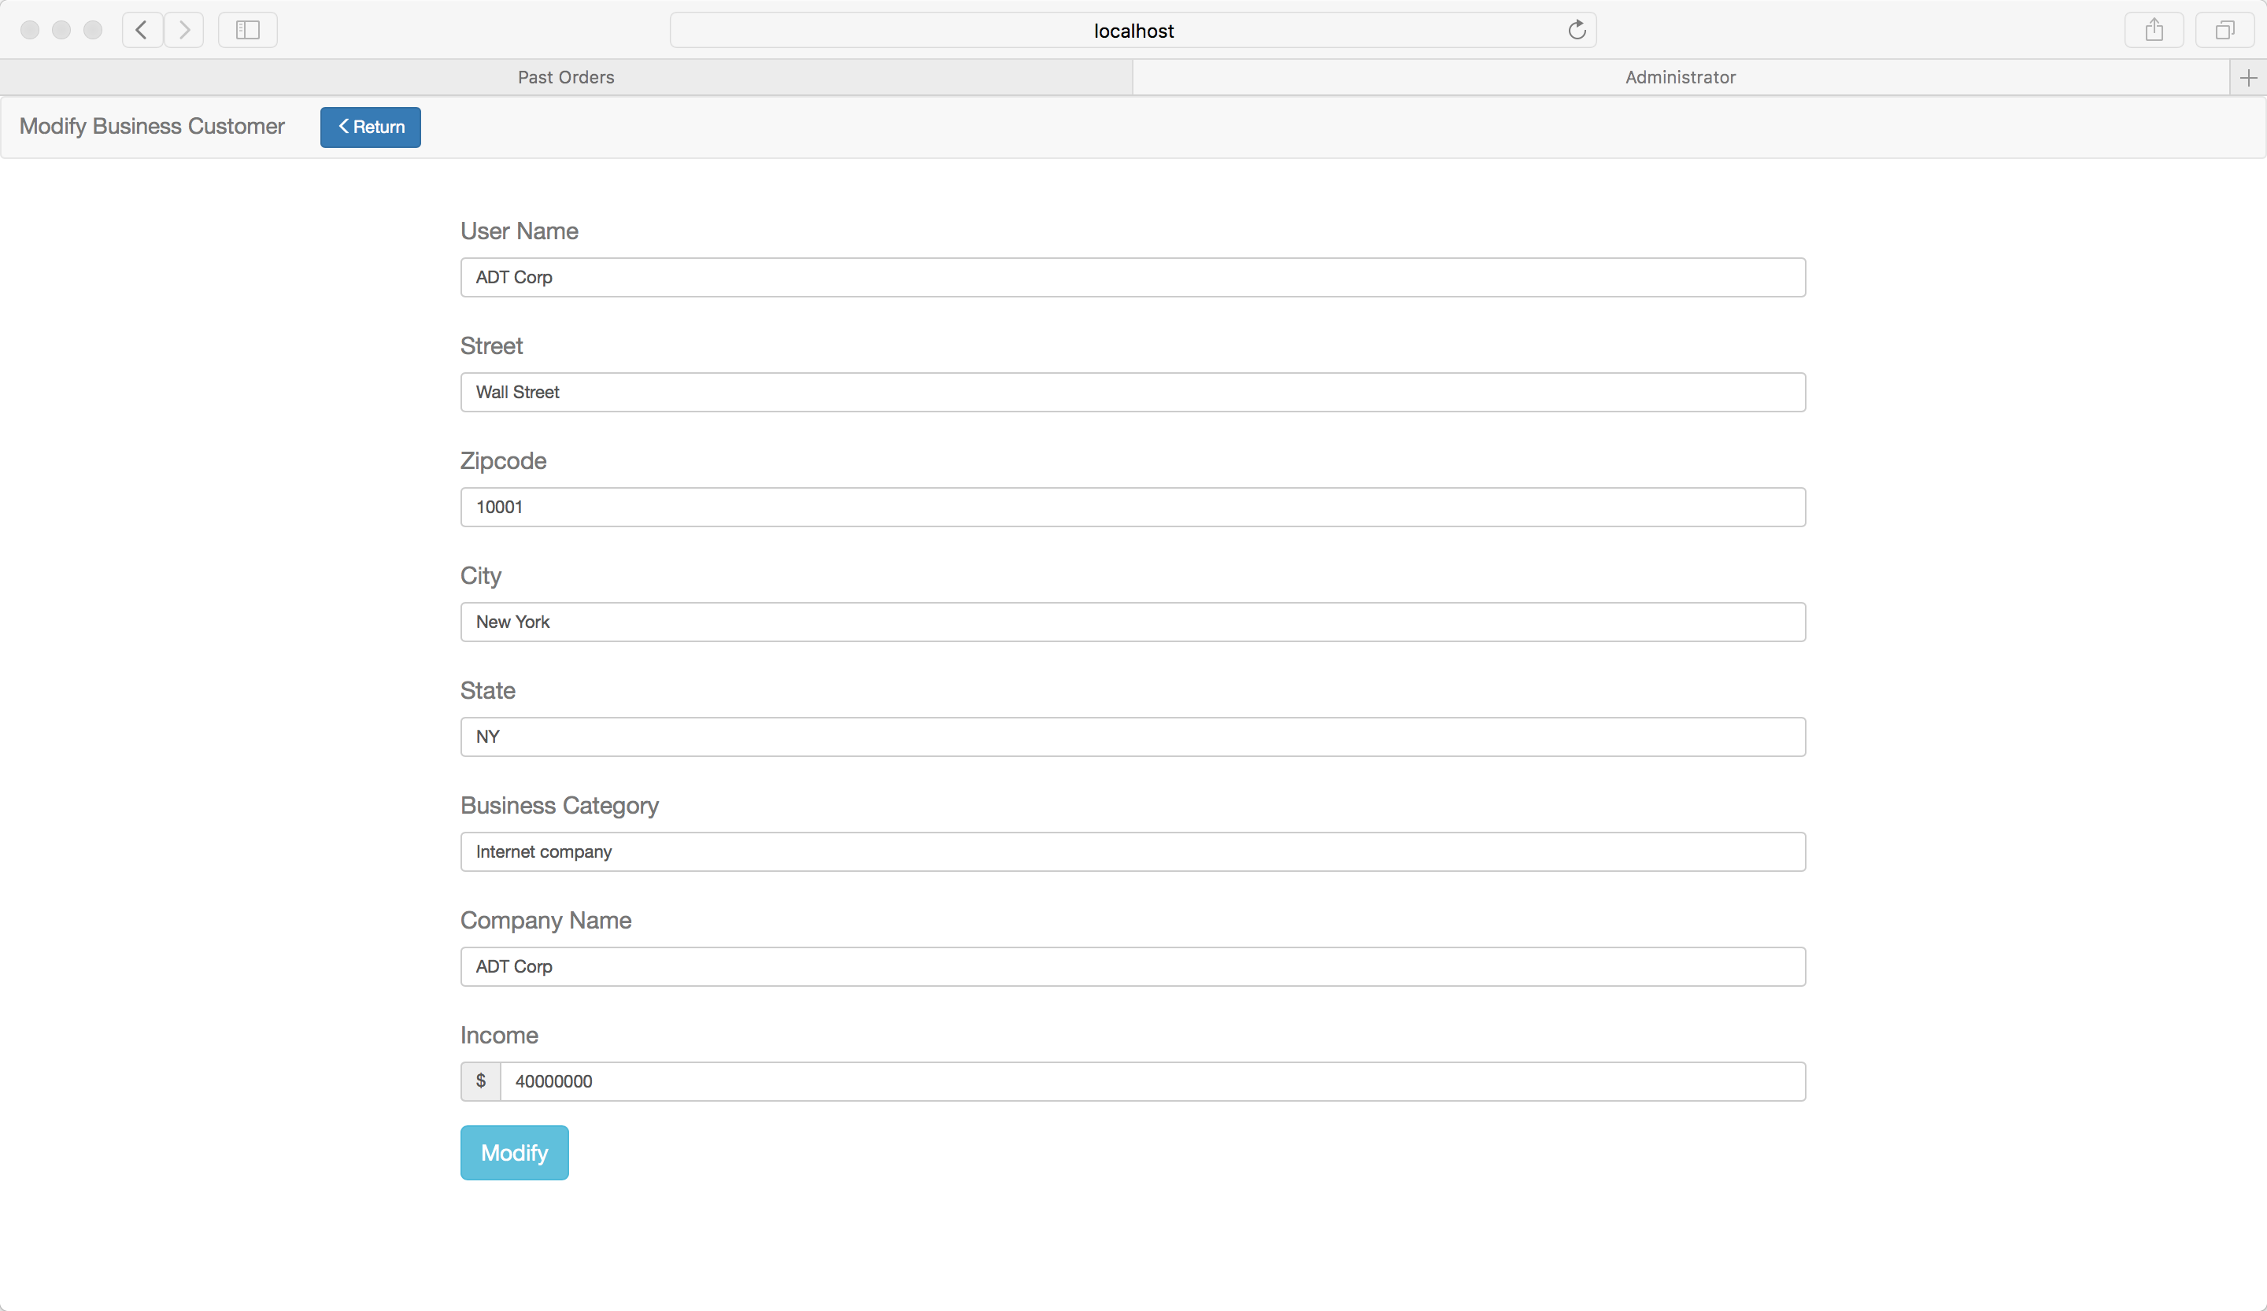

*Figure 7.2.6 Modify Customers*

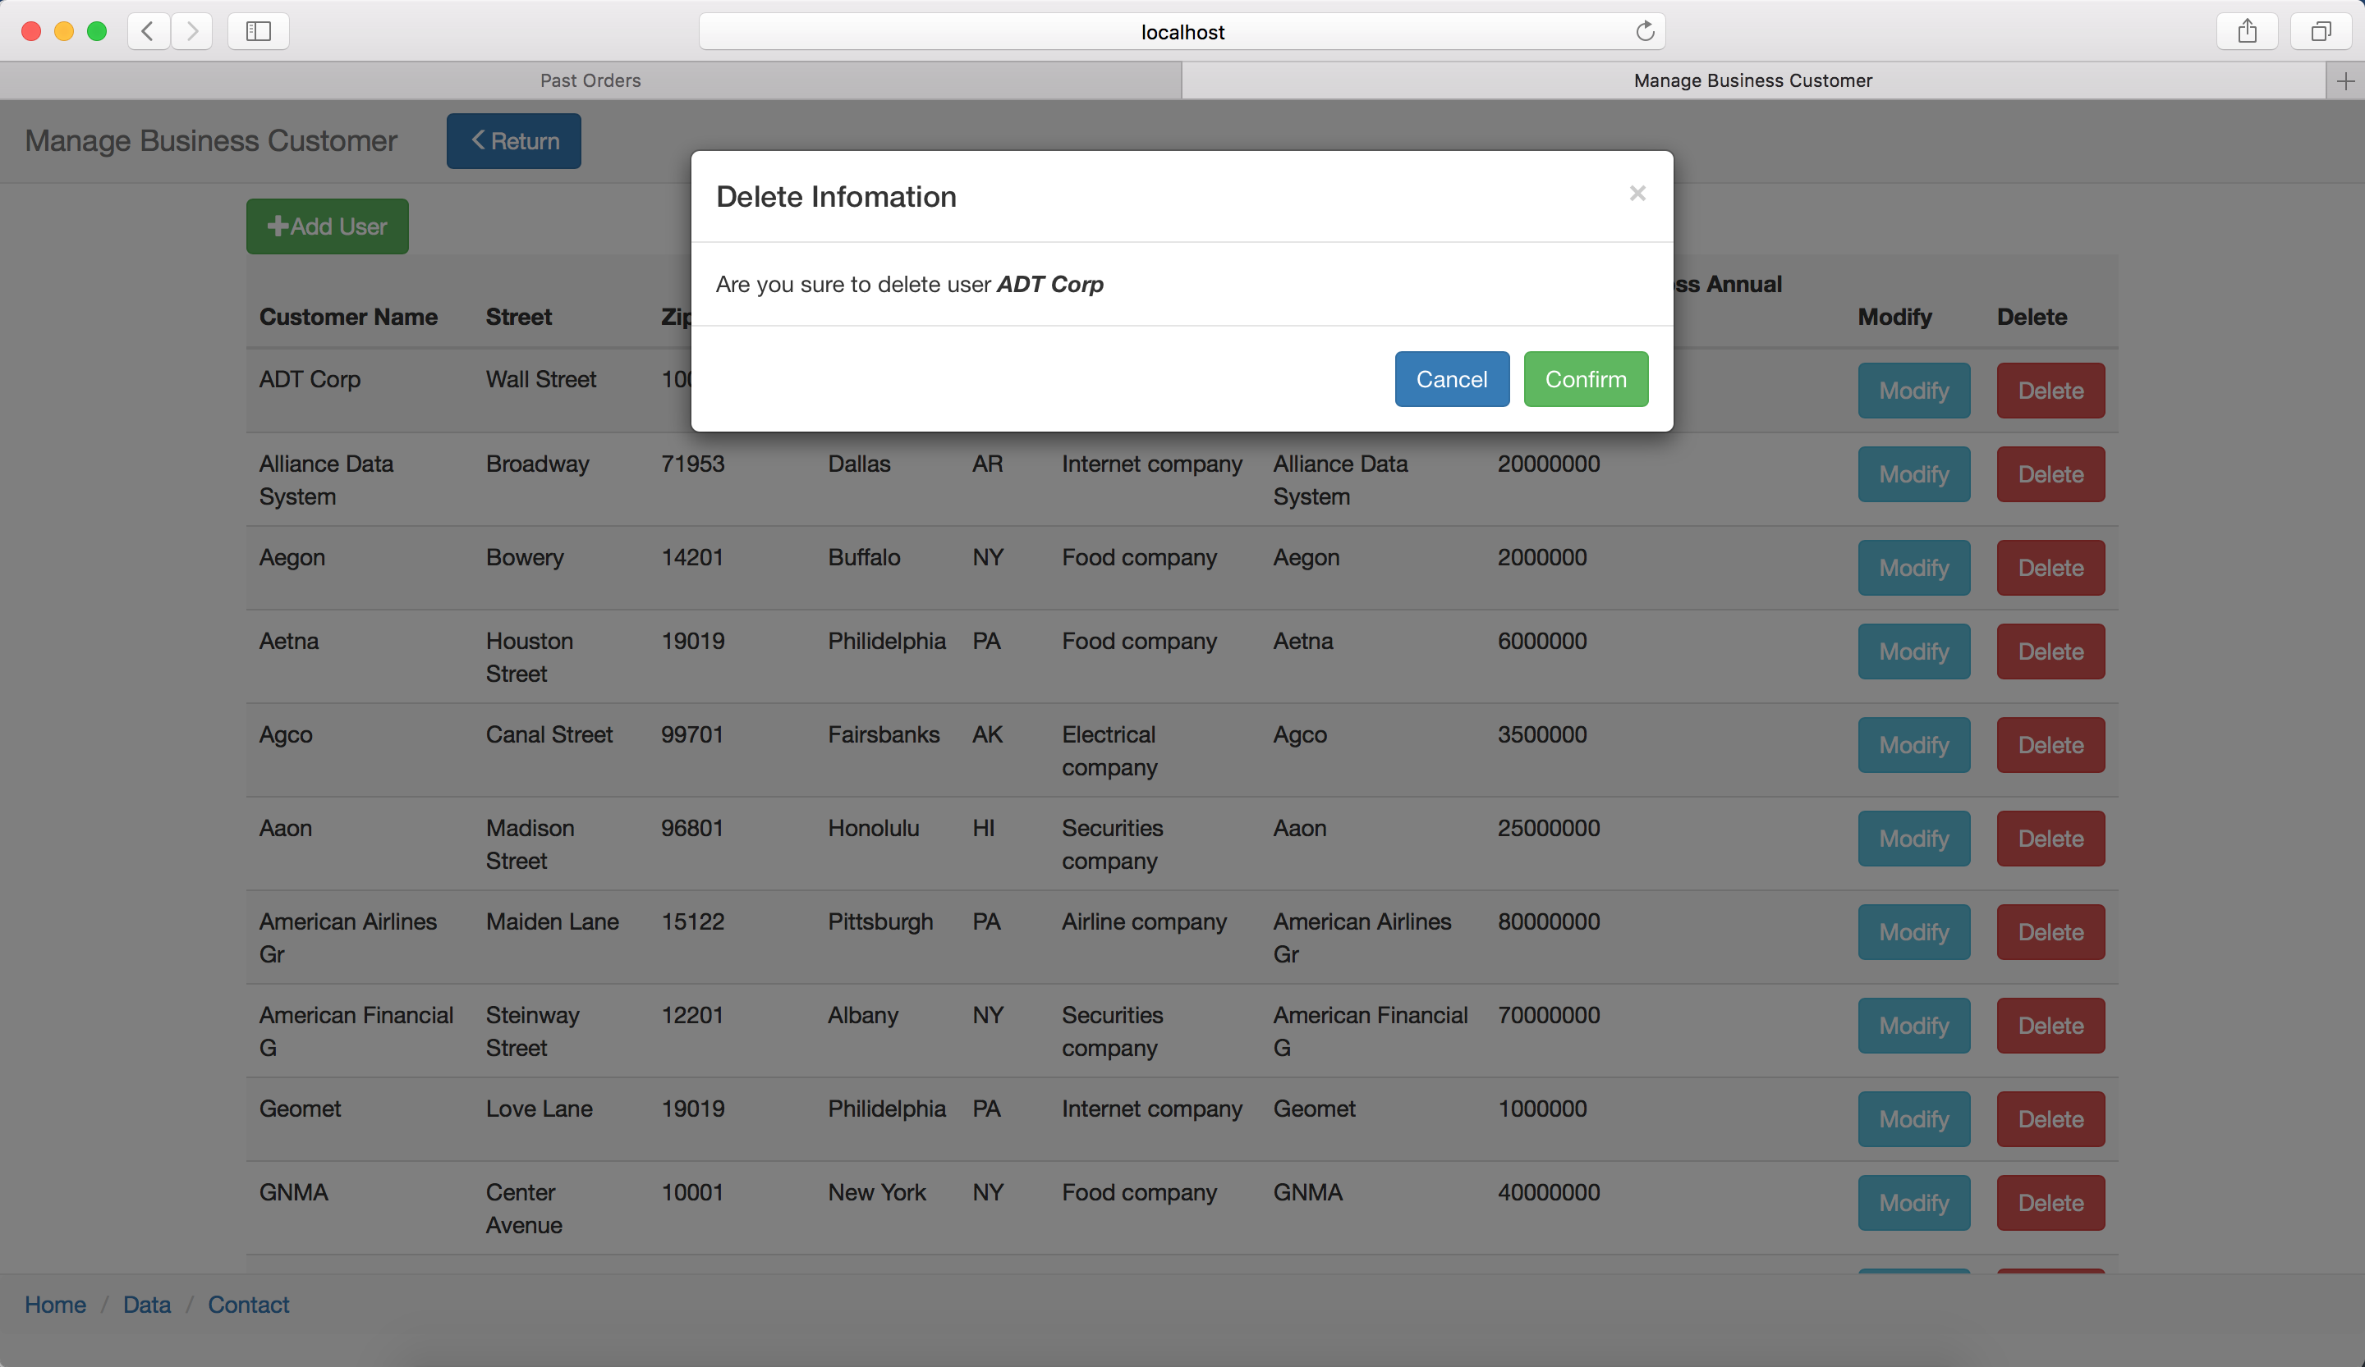

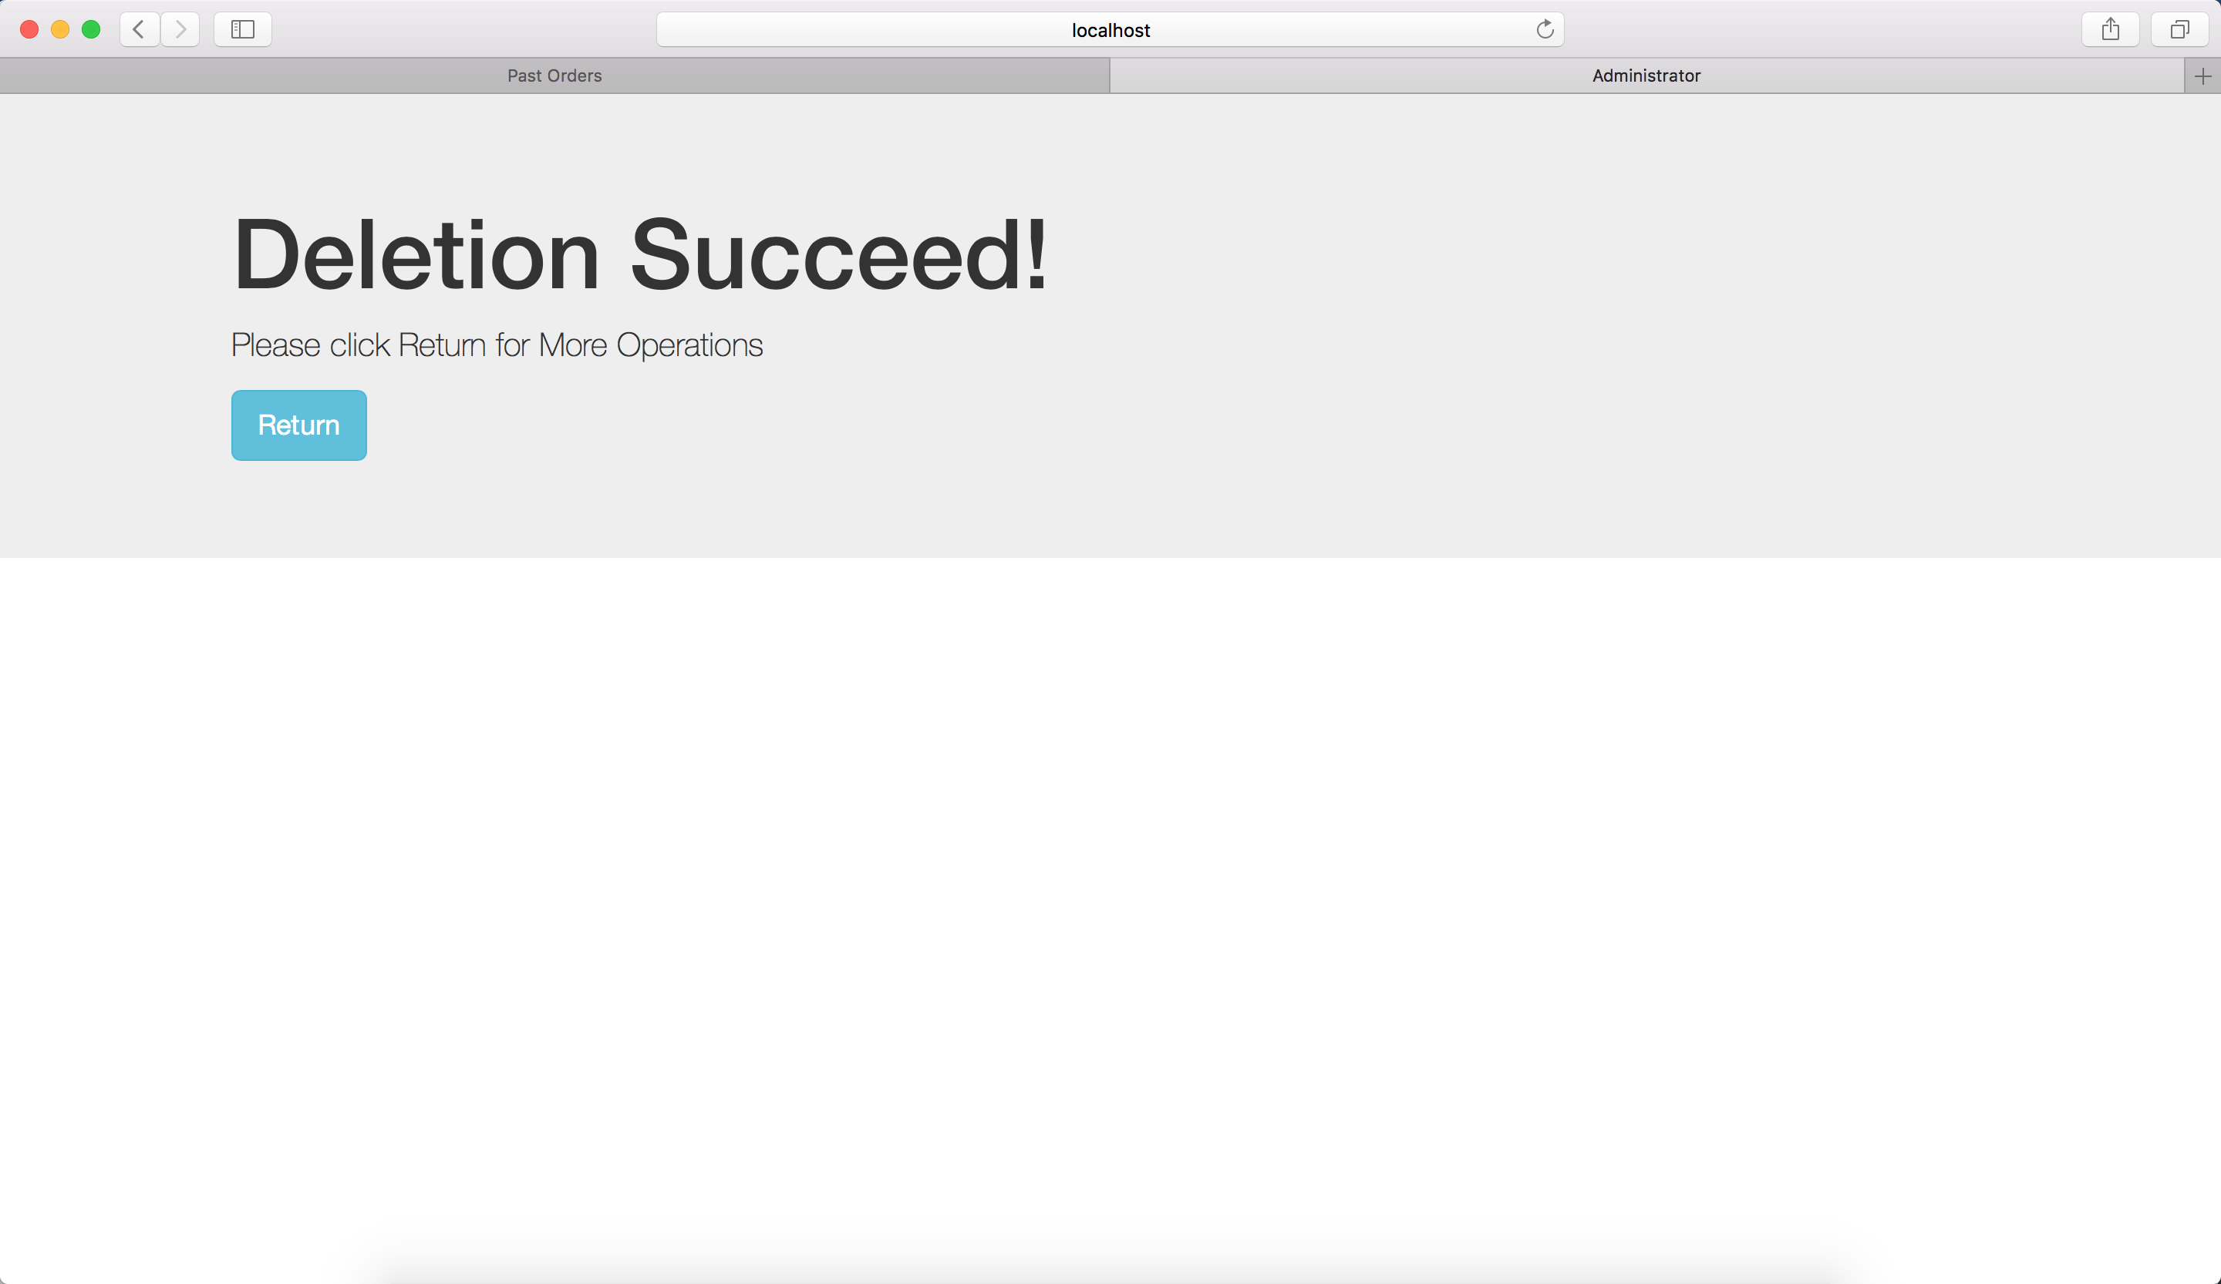

*Figure 7.2.7 Delete Customers*

# 8. Testing of Erroneous Cases

## 8.1 Erroneous Cases when Log up

When customers log up, they have to enter their username, and enter their expecting passwords twice.

### 8.1.1 Different Passwords

When the new users click “Sign up” button, the system will first check if the two passwords match one another. If not, the system will warn the users to return and enter the passwords again.

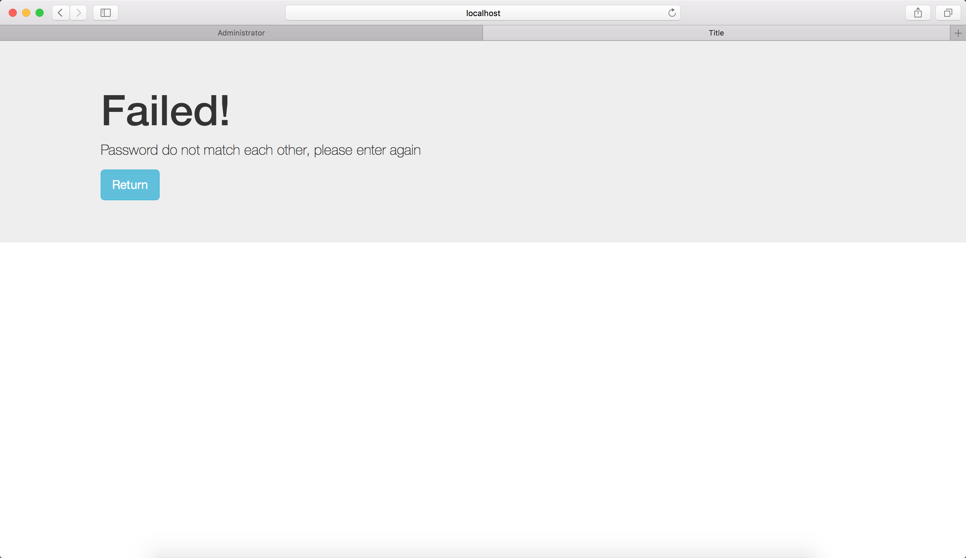

*Figure 8.1.1 passwords do not match one another*

### 8.1.2 Duplicate Username

If the username the new user entered is already existed, the system will warn the user to change another username.

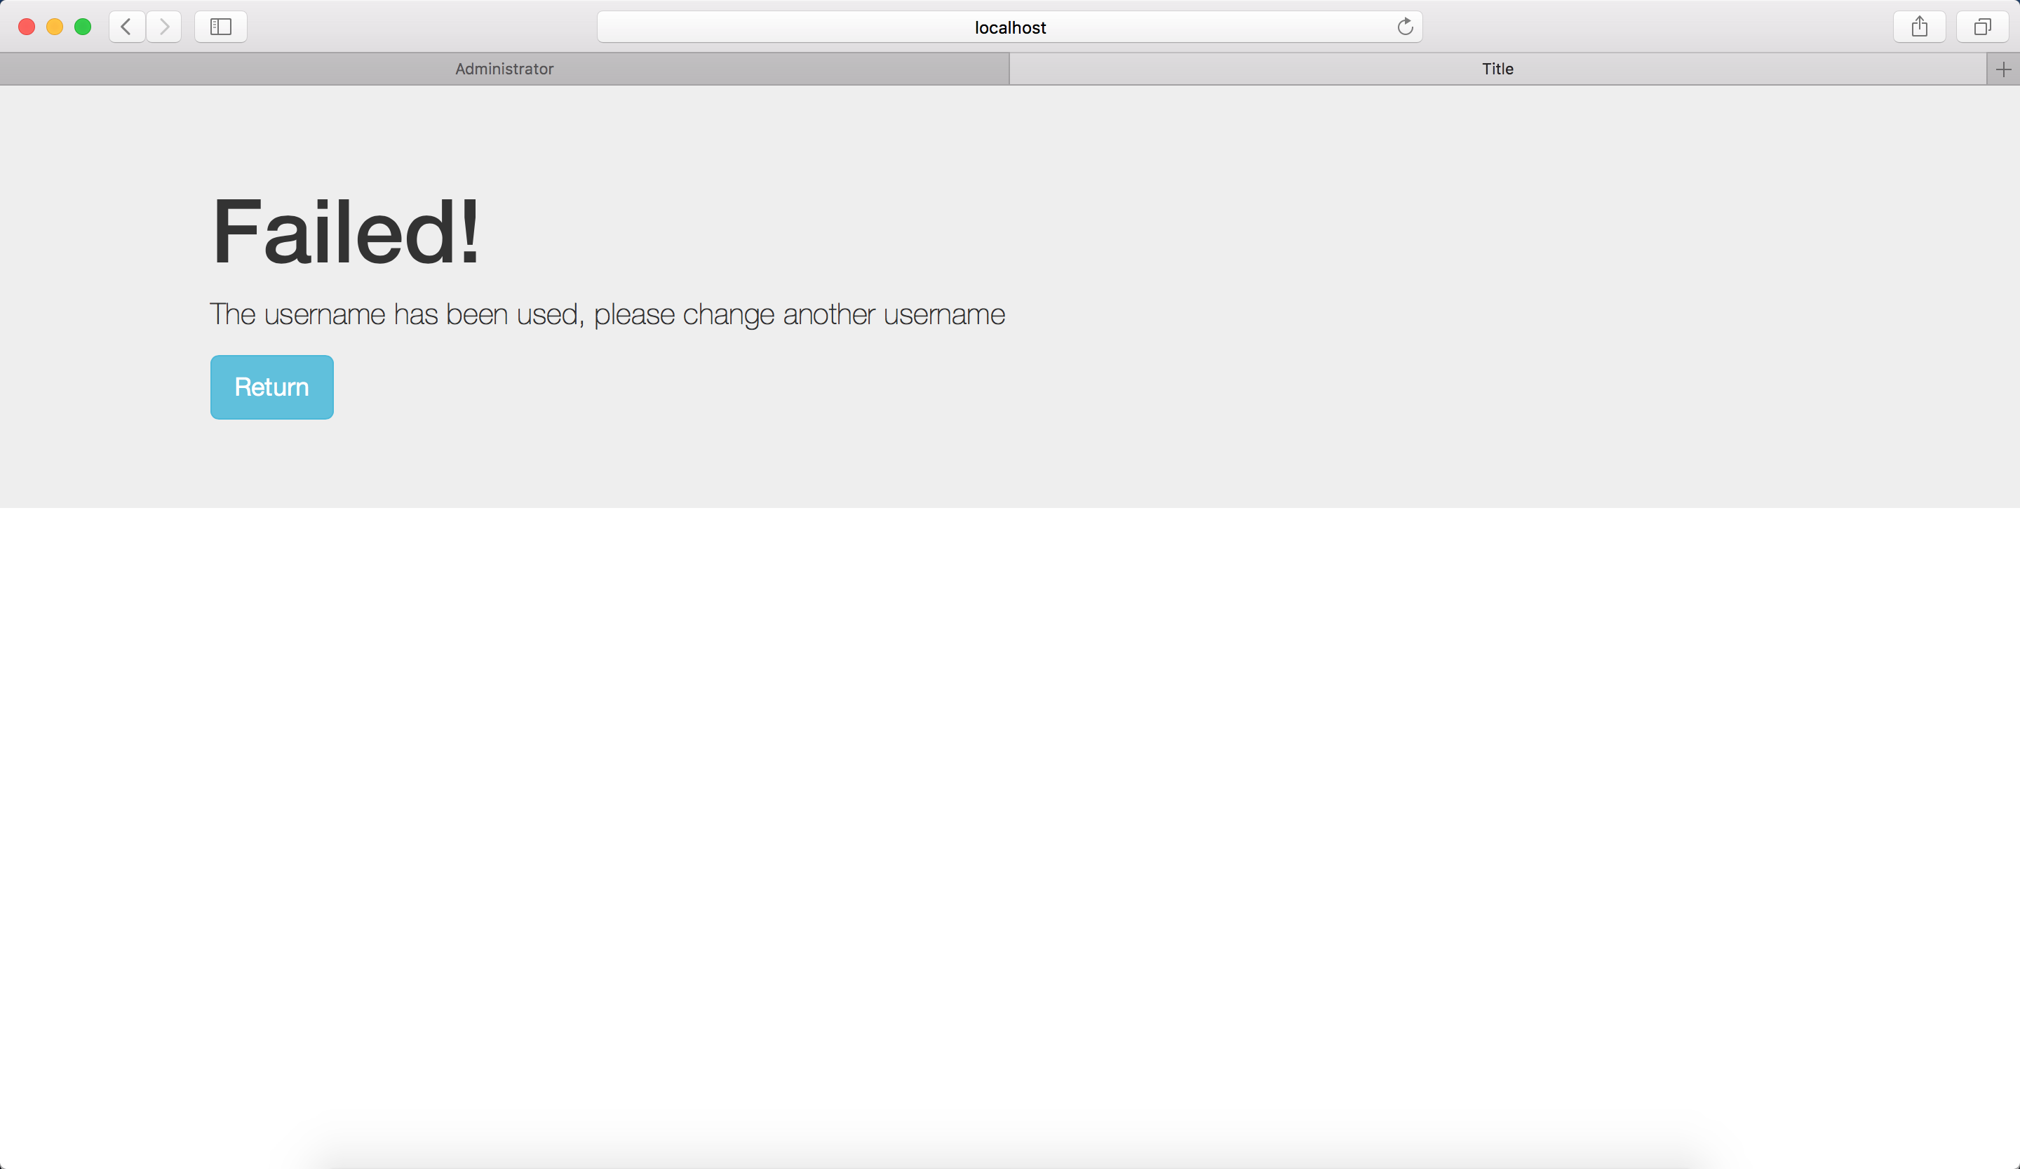

*Figure 8.1.2 duplicate username*

### 8.1.3 Input Error Messages in Zip Code, Age and Income

When customer inputs error messages or negative number in zip code, age and income, the system will detect them and input only positive number into the database.

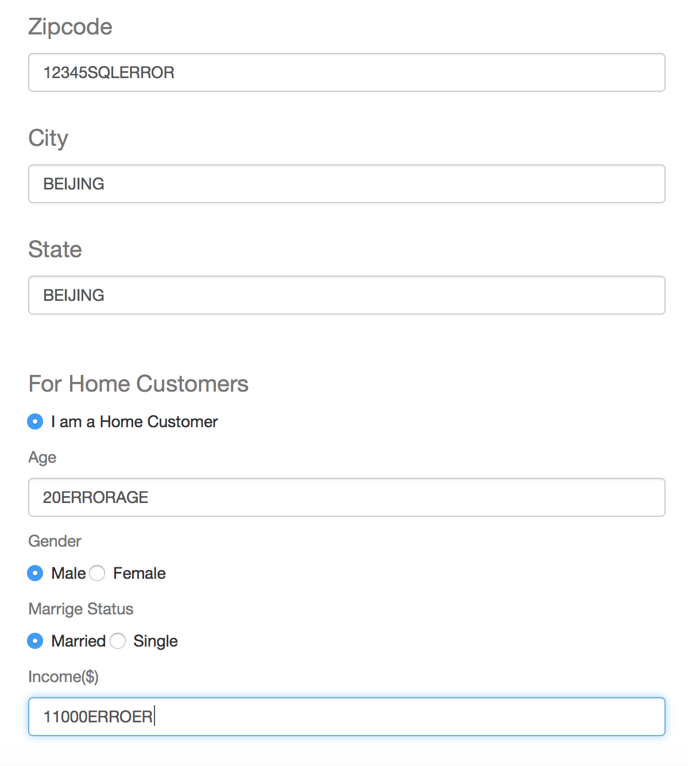

*Figure 8.1.3 Error messages when log up*

**

*Figure 8.1.4 System just inserts number into zip code, age and income*

## 8.2 Erroneous Cases when Log in

When the customer logs in, the system will check the username and the password with those in the database, if the username or password do not match, the system will not let the customer log in, instead it will warn the customer to try again.

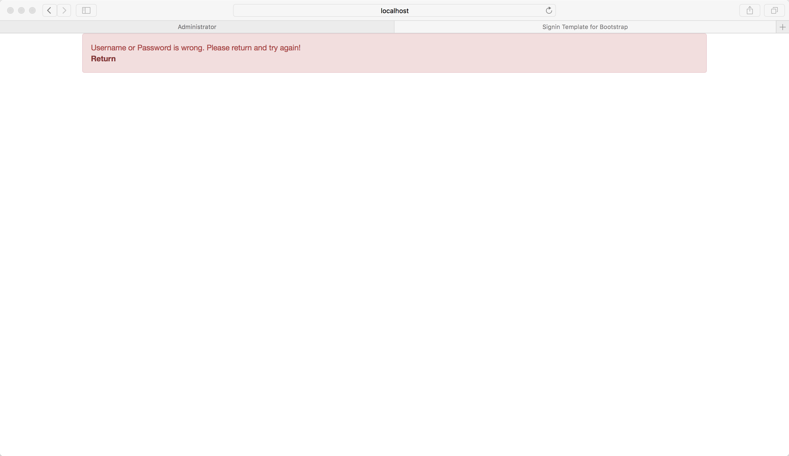

*Figure 8.2 username or password do not match*

## 8.3 Erroneous Cases when Making Transactions

The selecting quantity part in the browsing page has been set between 1 and the inventory amount in the database. If the inventory amount is 0, then if the customer selects 1 and click “Buy” button the system will warn the customer that the current amount is 0, and the purchase is not successful.



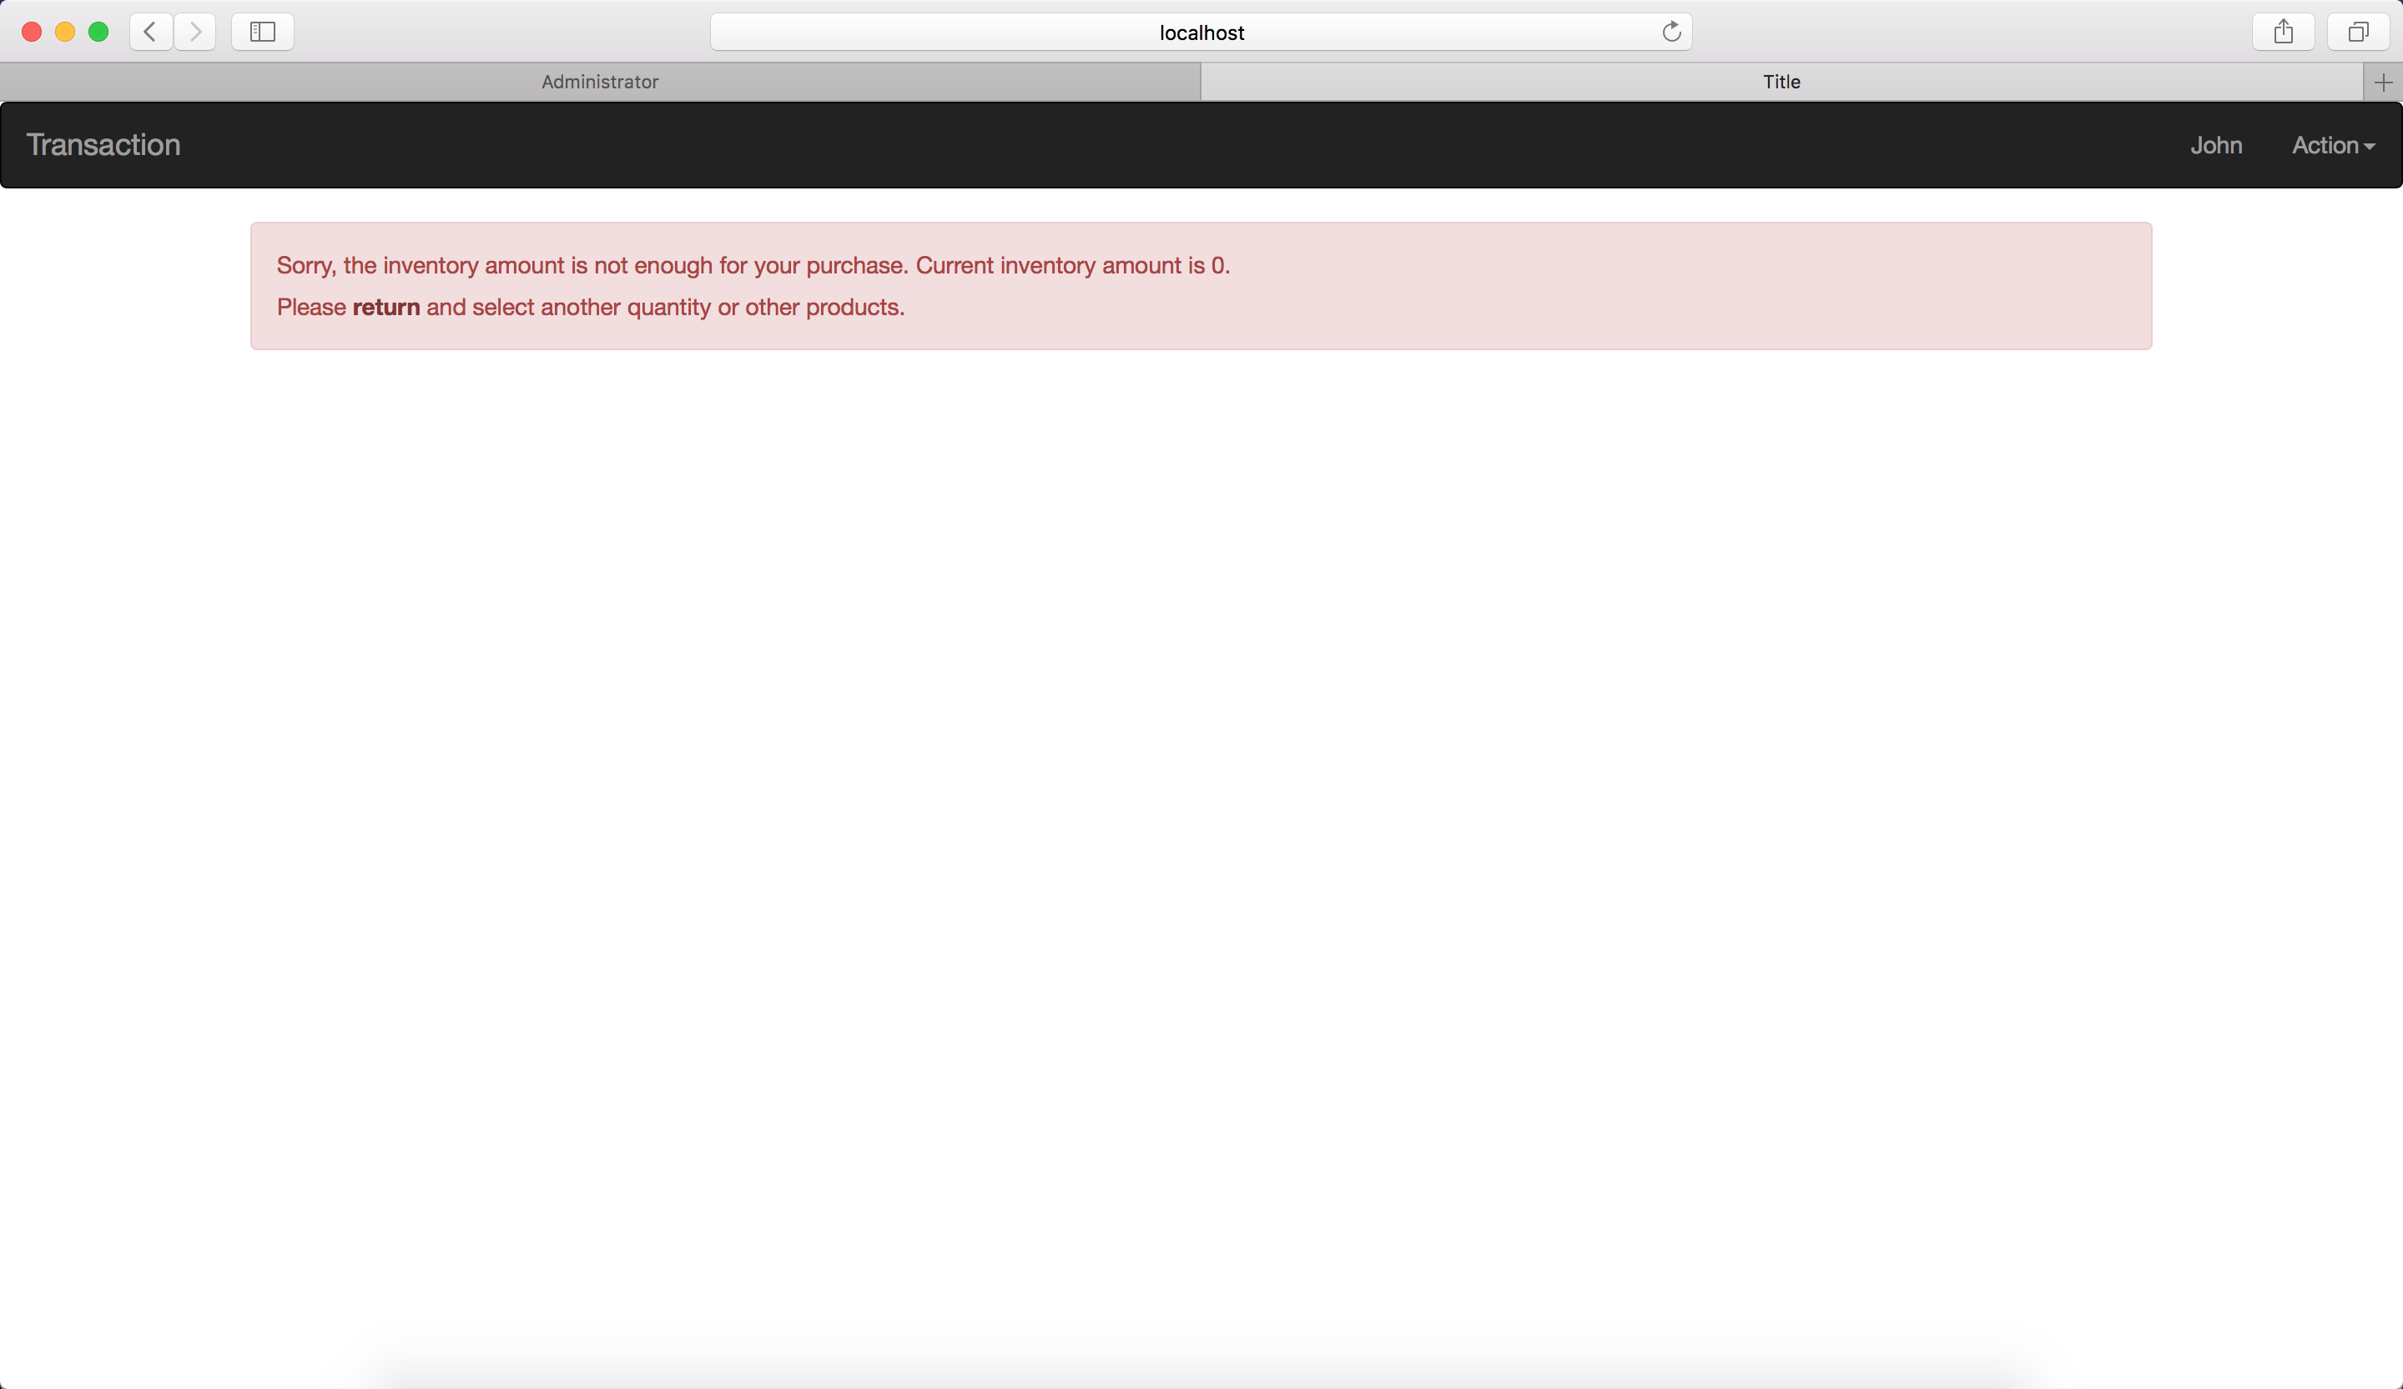

*Figure 8.3.1 not enough inventory amount for purchase*

In another case, if the customer does not select a quantity, instead she/he chooses to enter a quantity that is larger than the inventory amount, the system will also detect this situation, and warn the customer to change the quantity, and this transaction will not be successful either.





Figure 8.3.2 the quantity of purchase is larger than inventory amount

## 8.4 Erroneous Cases when Adding New Products

### 8.4.1 Adding Existed Products

In the administrator pages, when one administrator tries to add an existed product, the system will detect that and warn the administrator to modify the information of the new product.

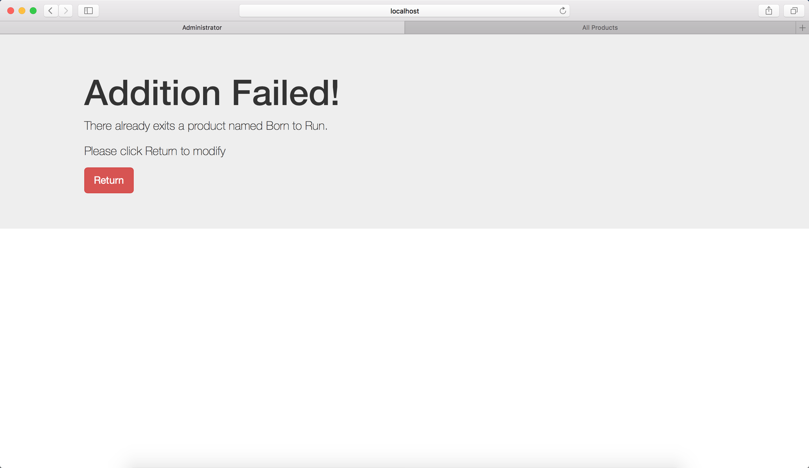

*Figure 8.4.1 adding an existed product*

### 8.4.2 Input Negative Value or Error Information on Price and Inventory Amount

If administrators input negative value or information other than numbers on price or inventory amount when adding a new product or modify an existed product, the system will detect that error information and automatically change them to the right format.

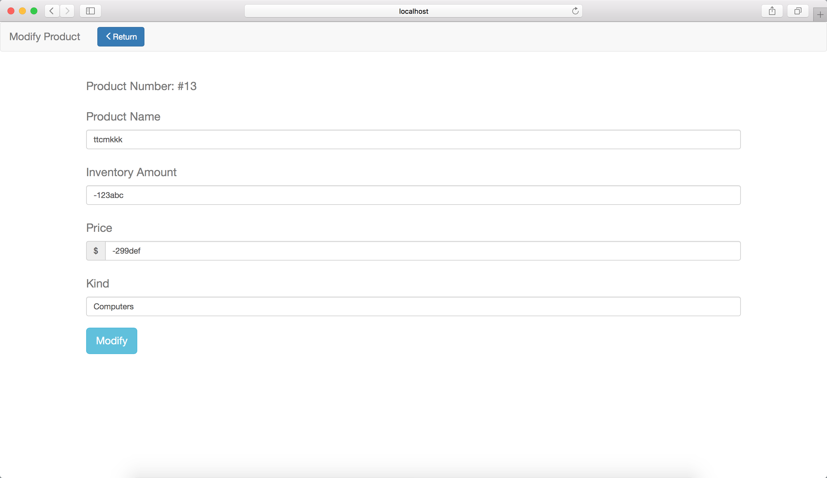

*Figure 8.4.2 Input error information*

**

*Figure 8.4.3 System detect error information and modify*

# 9. Reviews and Improvements

This system has been done by three of us, and the lack of communications is one of the limitations in the system. Due to that, this system exists some inconsistencies, for example, the data in database may conflict with one another, and it takes us much time to modify and make it consistent. The improvement method is simple for this limitation, which is, make a more detailed documented plan to standardize our individual works, so the whole system will not suffer from the inconsistencies.

Another limitation of our system is that when one page jumps to another page, we use some invisible forms to carry some information such as the username, the region the user chose, or the salesperson’s id when customer makes a purchase. Although it is working correctly, the efficiency of the system may decrease a lot. So the possible improvement is that we can use session or cookie as a tool to carry all the information we need in the whole transaction, so whenever we need them, we can easily pick them out from the session or cookie. However, if the customer clicks “log out”, we should clear all the sessions or cookies owned to this customer.